# Classification of Drug Consumption Dataset

## 1.0 Introduction

Classification is a supervised machine learning task widely applied in various domains to predict categorical outcomes based on input features (Sisodia, 2018). The consumption of drugs has significant social and health implications, making it a critical area of study. Machine learning offers powerful tools to analyze such datasets, uncovering patterns and predicting behaviors based on demographic and psychological features (Breiman, 2001). This report examines the Drug Consumption (Quantified) dataset from the UCI Machine Learning Repository, leveraging machine learning techniques to classify consumption behaviors. The analysis aims to understand drug usage patterns, provide actionable insights, and explore how these findings can aid in addressing drug-related societal challenges.

## 2.0 Dataset Description and

The Database contained records for 1885 respondents. For each respondent 12 attributes were known: Personality measurements which include NEO-FFI-R (neuroticism, extraversion, openness to experience, agreeableness, and conscientiousness), BIS-11 (impulsivity), and ImpSS (sensation seeking), level of education, age, gender, country of residence and ethnicity were in the dataset.

The dataset also had targets concerning the use of 18 legal and illegal drugs (alcohol, amphetamines, amyl nitrite, benzodiazepine, cannabis, chocolate, cocaine, caffeine, crack, ecstasy, heroin, ketamine, legal highs, LSD, methadone, mushrooms, nicotine and volatile substance abuse and a fictitious drug (Semeron) (UCI repository)

For this analysis, Random Forest and Support Vector Machines (SVM) on all the targets in the dataset.

## 2.1 Exploratory Data Analysis

The Initial exploration involved analyzing data distributions, identifying missing values, and examining feature correlations(Breiman, 2001). The first thing that was done was to make sure that the ucimlrepo repository was installed to make sure that the dataset from the UCI Machine Learning Repository was imported. The required libraries need for the analysis were imported. This imports Python libraries essential for data manipulation, visualization, preprocessing, and machine learning.

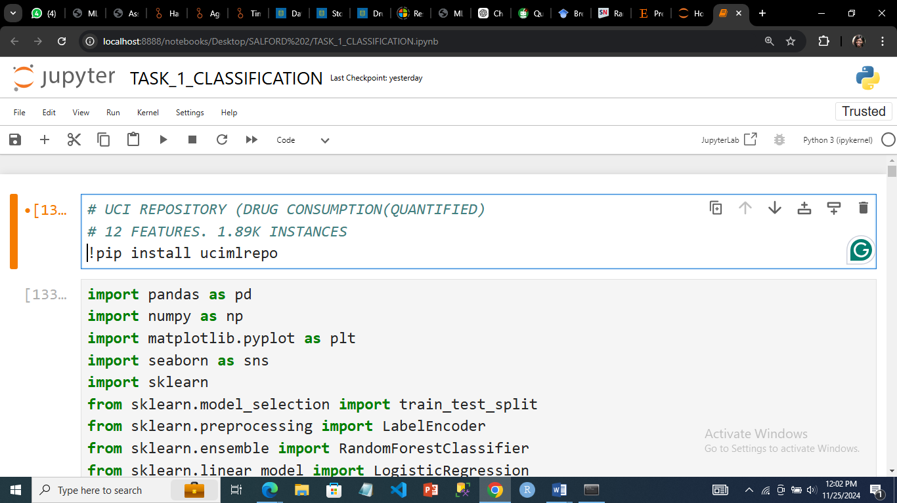

*Installing the UCI MACHINE LEARNING REPOSITORY*

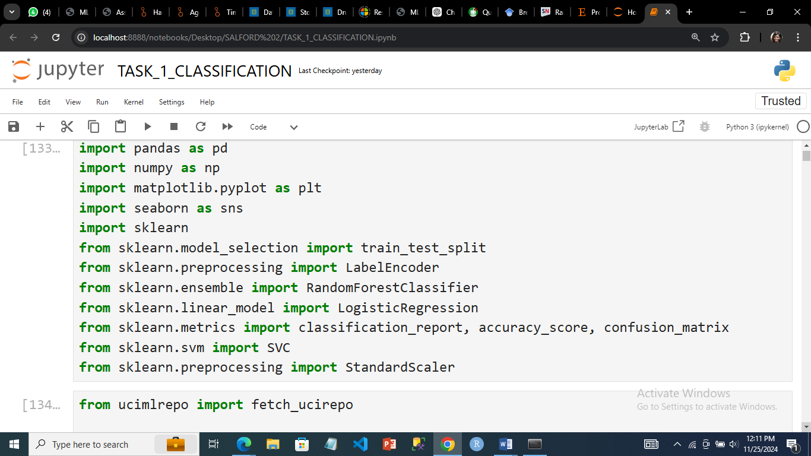

*Python libraries*

The fetch_ucirepo function retrieved the dataset using an identifier (id=373) specific to the "Drug Consumption (Quantified)" dataset. The independent variables (features) were assigned to X, and the target variable were assigned to y. The features and targets were combined into a single dataframe.

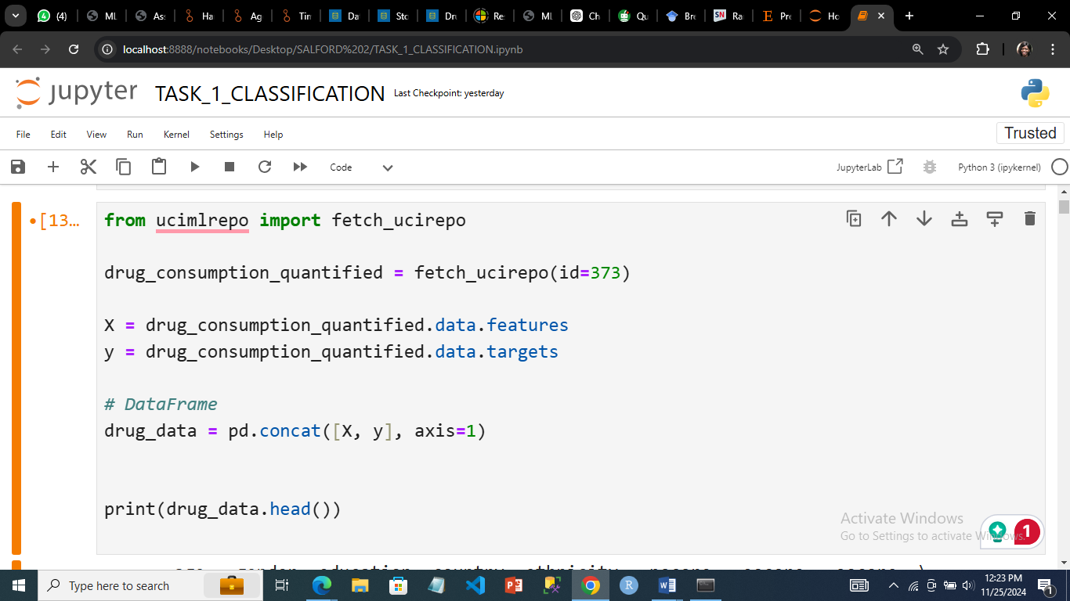

*The code to import the dataset*

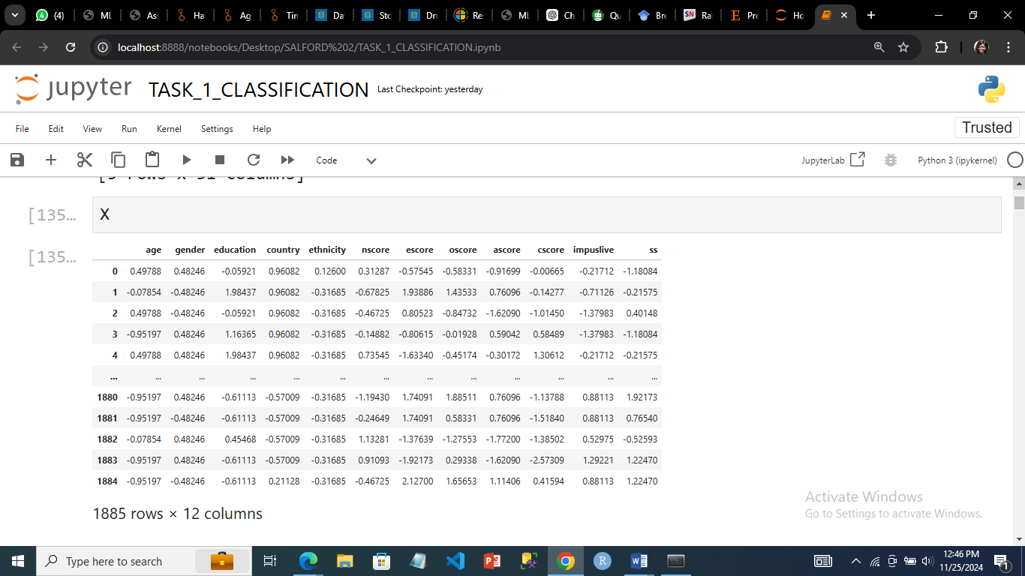

*The dataset features*

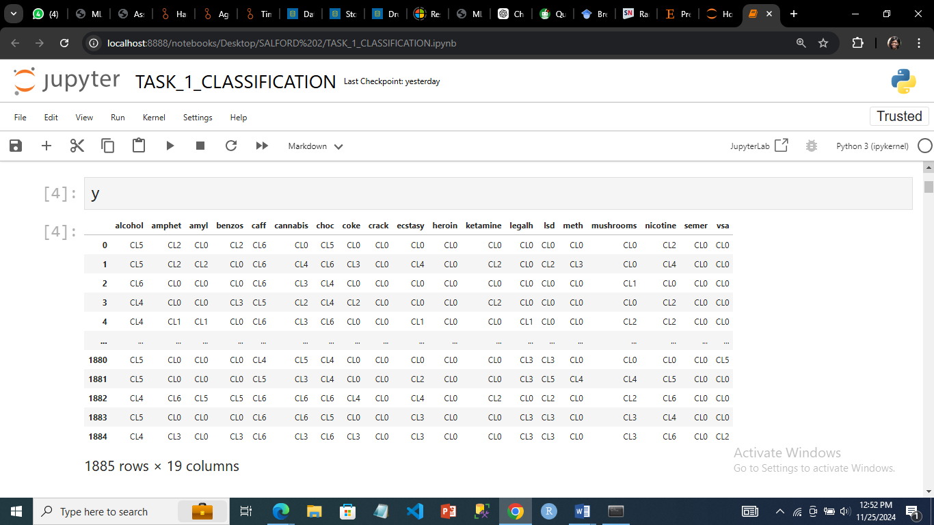

*The dataset targets*

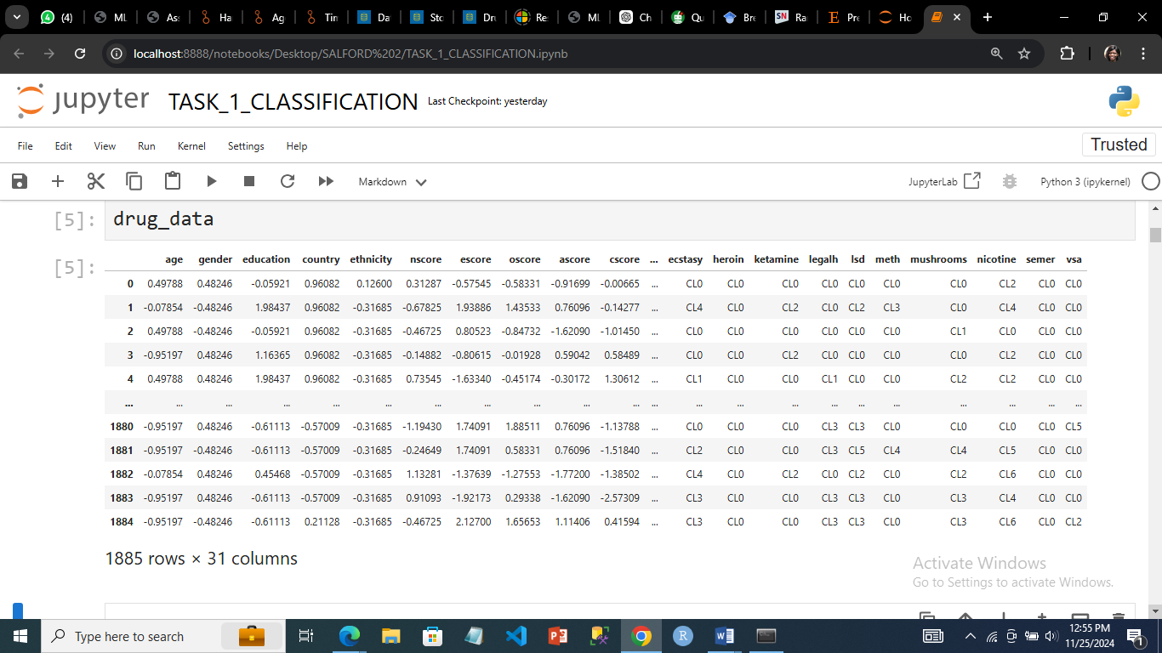

*The dataset with targets and features*

Exploratory Data Analysis (EDA**)** was critical in this machine learning pipeline as provides a comprehensive understanding of the dataset's structure, uncovering trends, anomalies, or patterns that could influence the modeling process. In revealing the distribution of the features, histogram visualization was done (Sisodia, 2018).

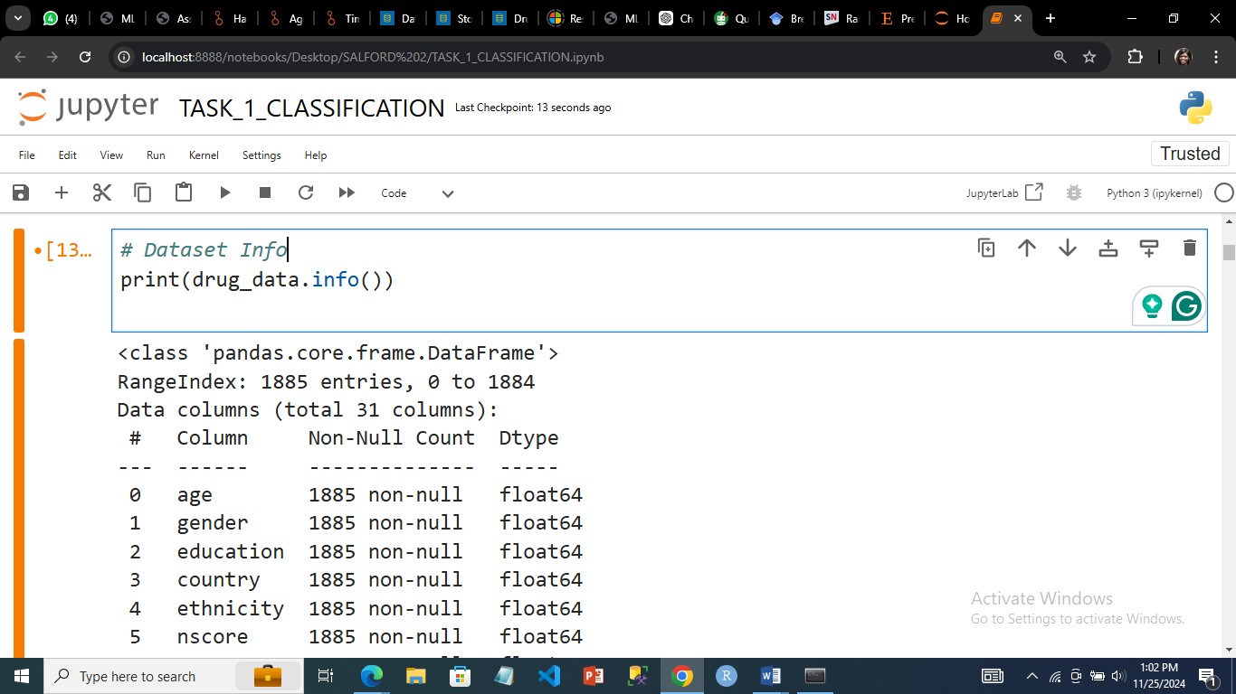

*The dataset info*

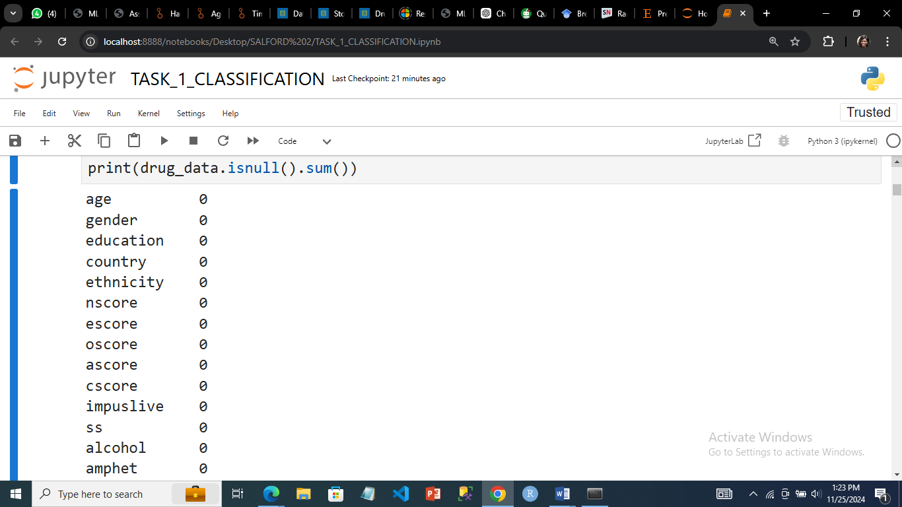

*The dataset had no missing value*

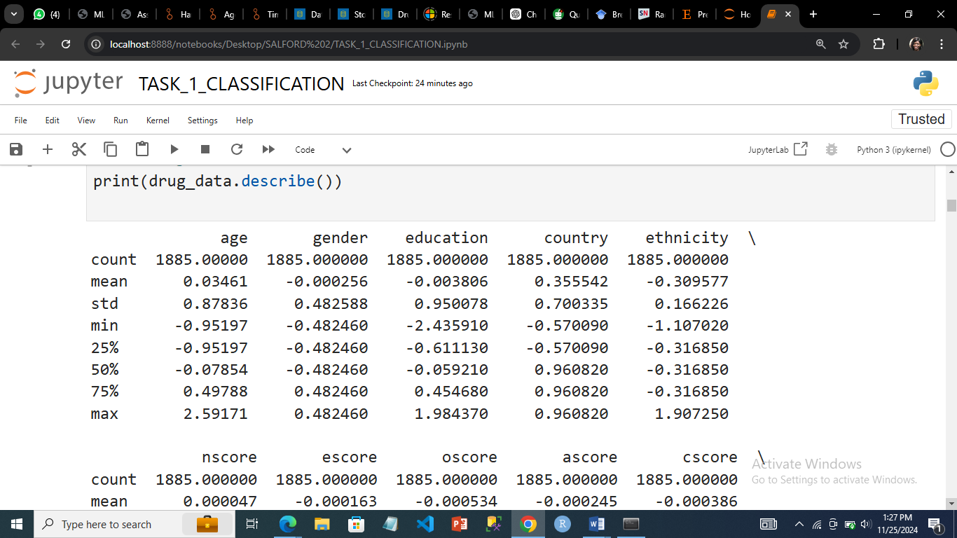

*Describing the data*

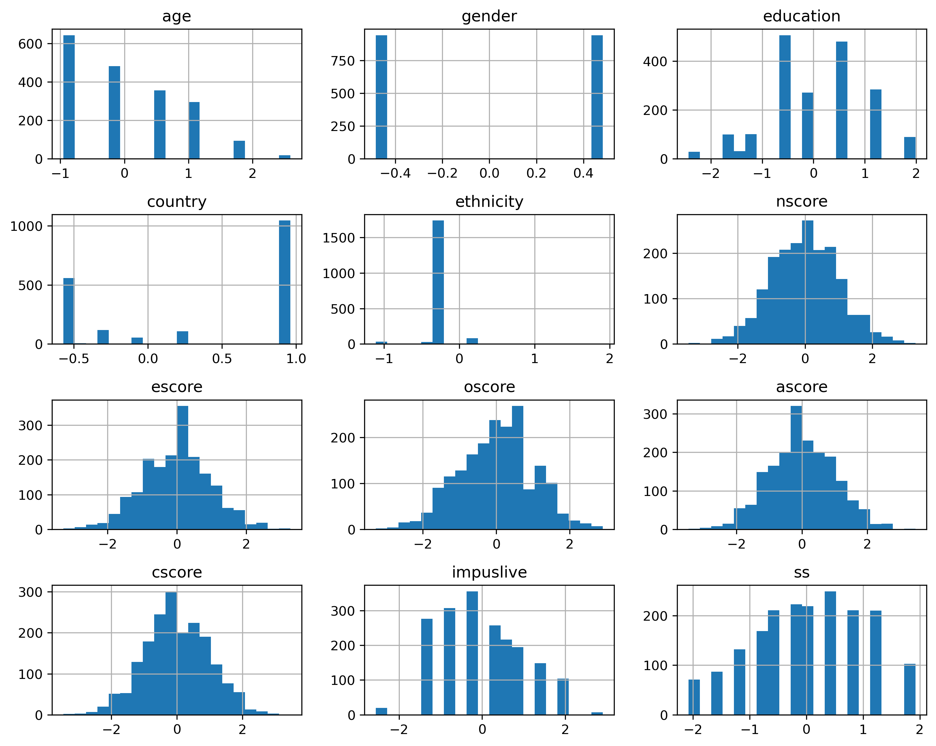

*Histogram showing the distribution of the dataset*

## 3.0 Data Preprocessing

Data preprocessing was essential to ensure data quality and compatibility with machine learning algorithms. The first thing that was done was to know each column and their indexes, this is to make sure that the right target is used in modelling.

In ensuring data quality, since there were no missing values in the dataset, standardization was done on the dataset to ensure that the features were scaled using StandardScaler. The features of the dataset were numerical, the StandardScaler was used to improve the classification algorithms performance. The fit_transform method applies scaling to the training set, while transform applies the same scaling parameters to the testing set, avoiding data leakage.

The dataset was divided or split into training and testing sets in an 80:20 ratios for model evaluation. The fixed random_state ensures reproducibility, making results consistent across runs. The training data was used to fit the models, while the testing data evaluates their performance on unseen data

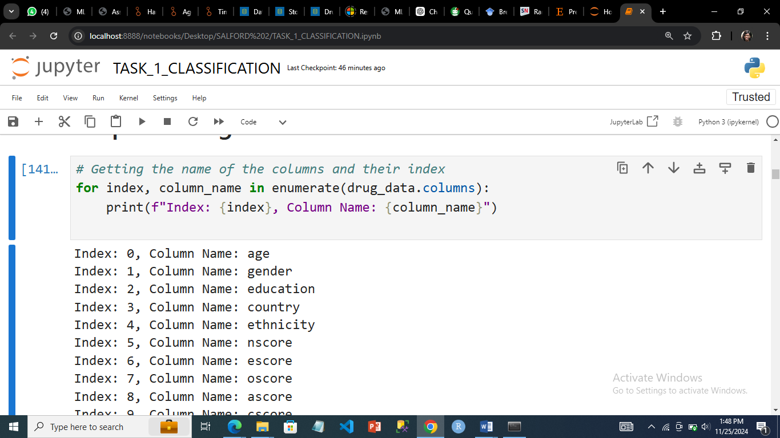

*Columns and their indexes*

*Each target was processed and classification done separately.*

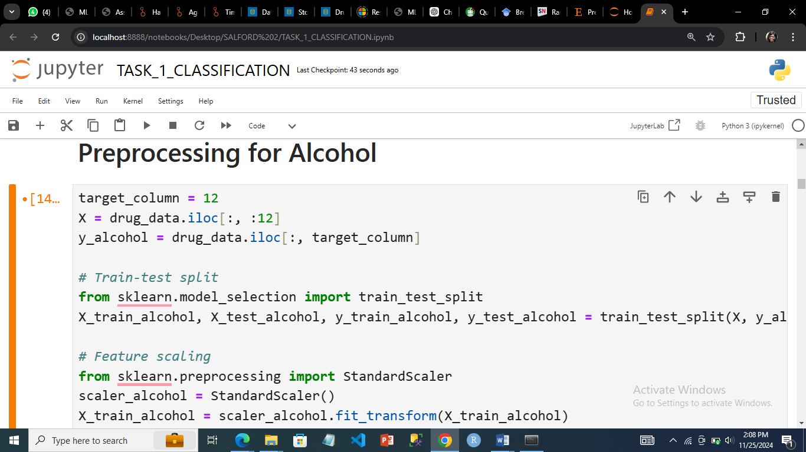

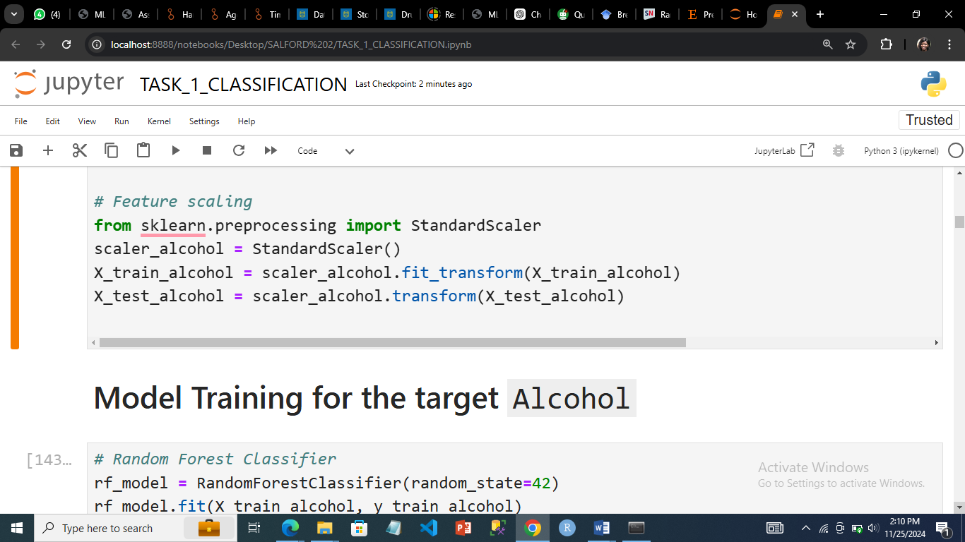

***Data processing and feature scaling for the target ALCOHOL***

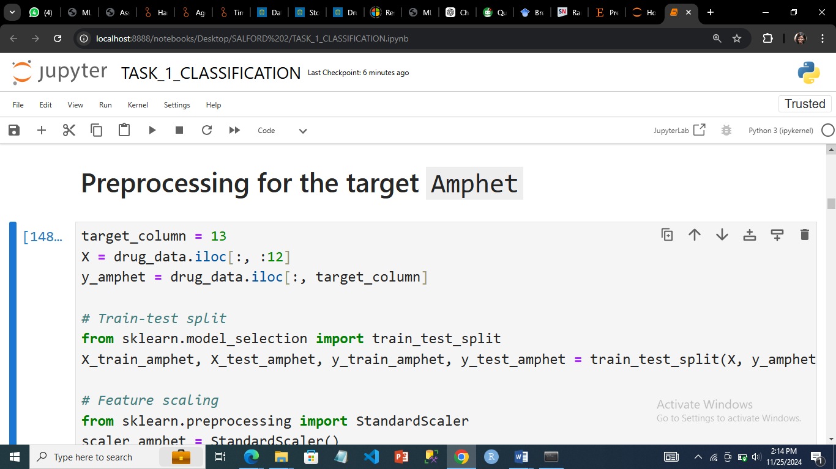

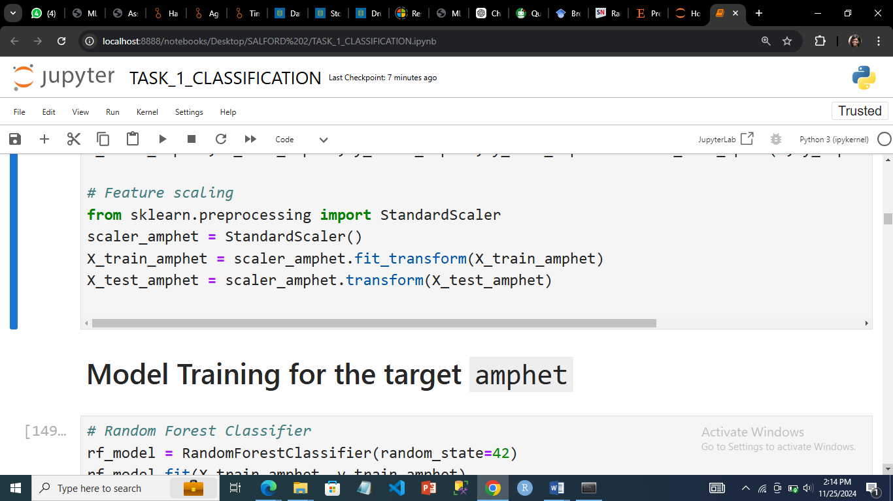

***Data processing and feature scaling for the target AMPHET***

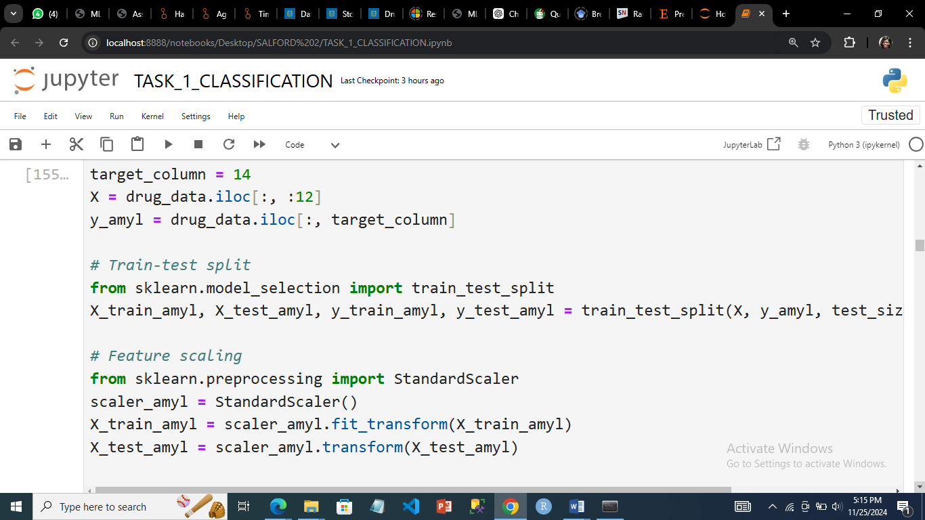



***Data processing and feature scaling for the target AMYL***

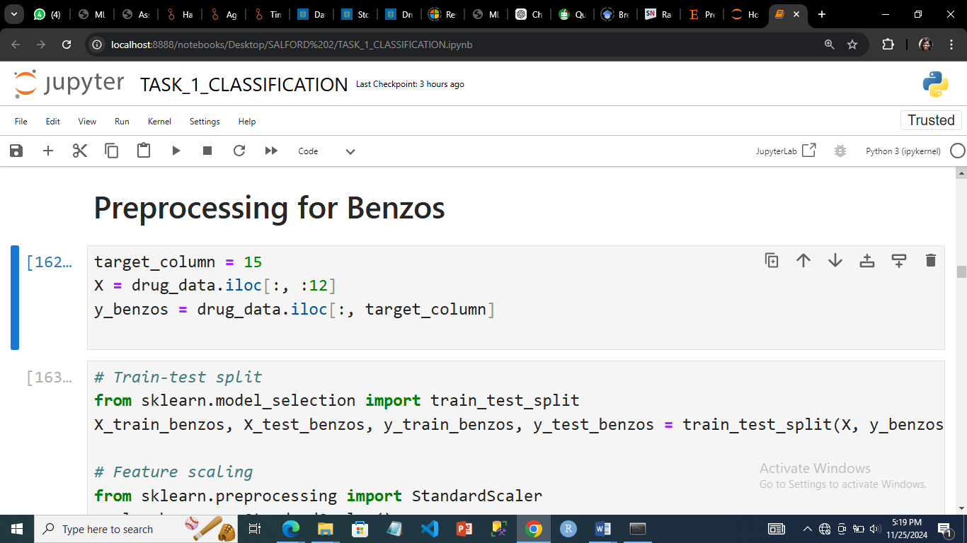

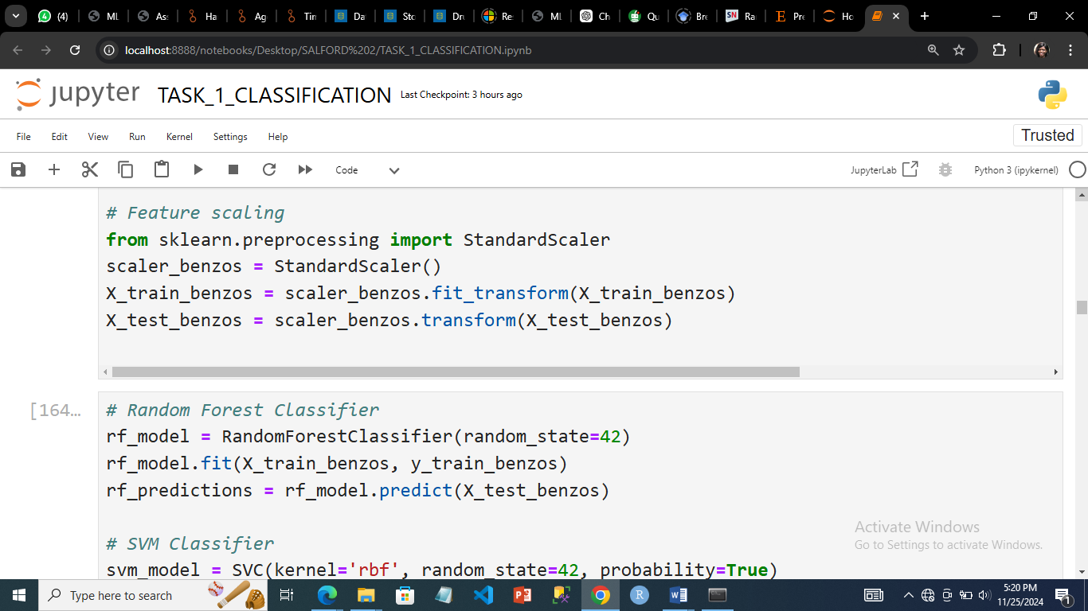

***Data processing and feature scaling for the target BENZOS***

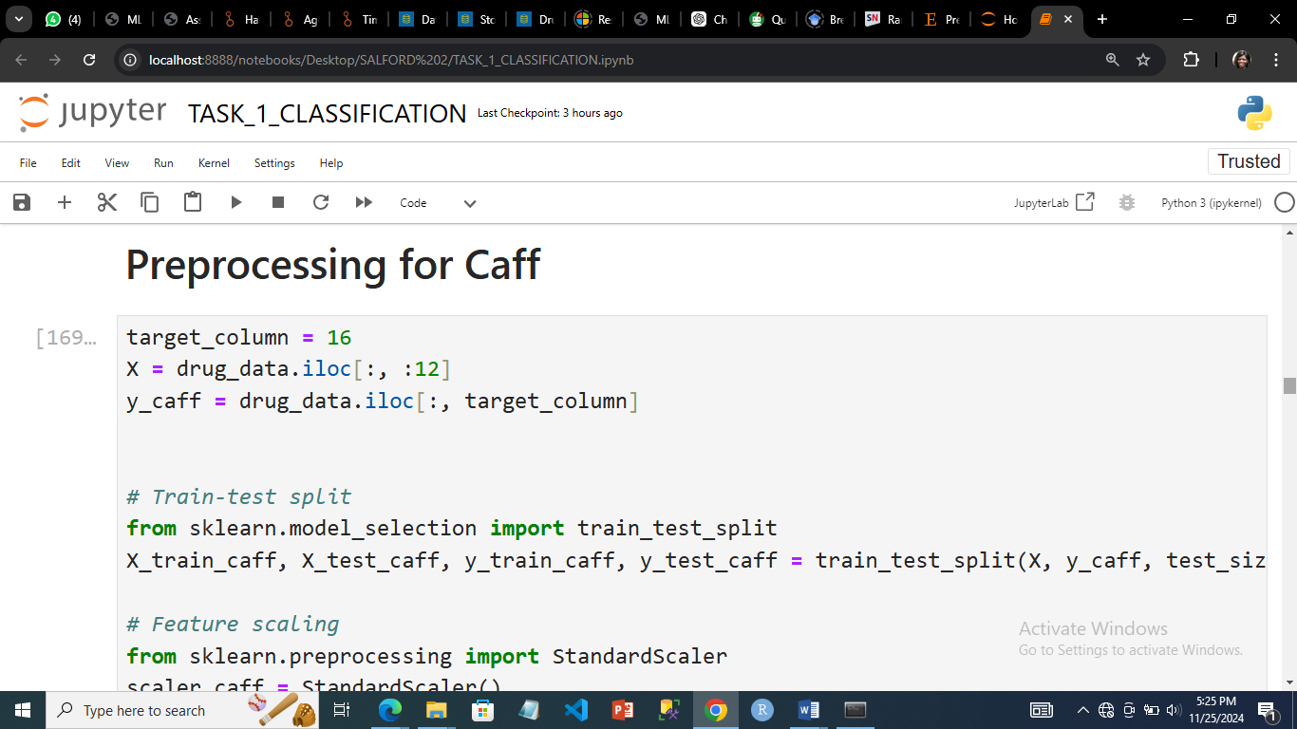

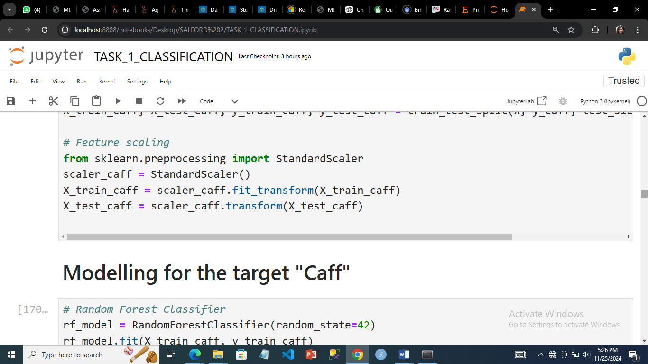

***Data processing and feature scaling for the target CAFF***

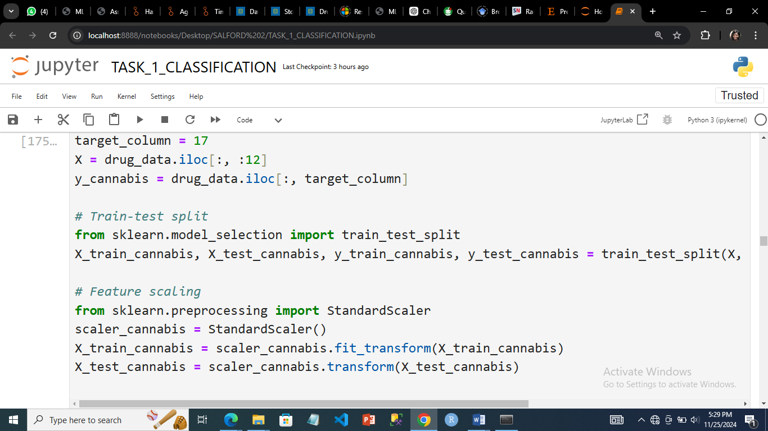



***Data processing and feature scaling for the target CANNABIS***

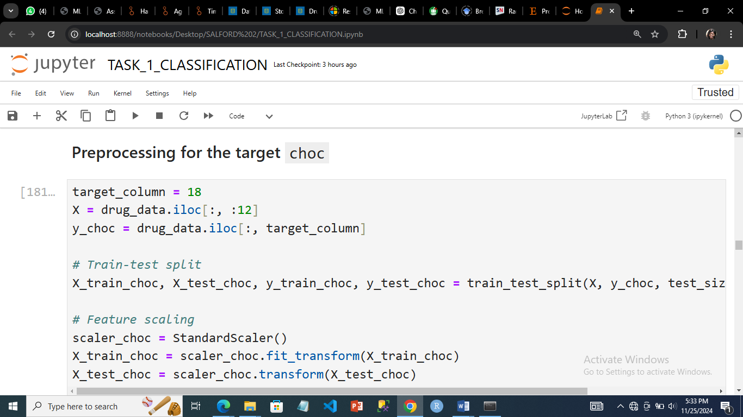



***Data processing and feature scaling for the target CHOC***

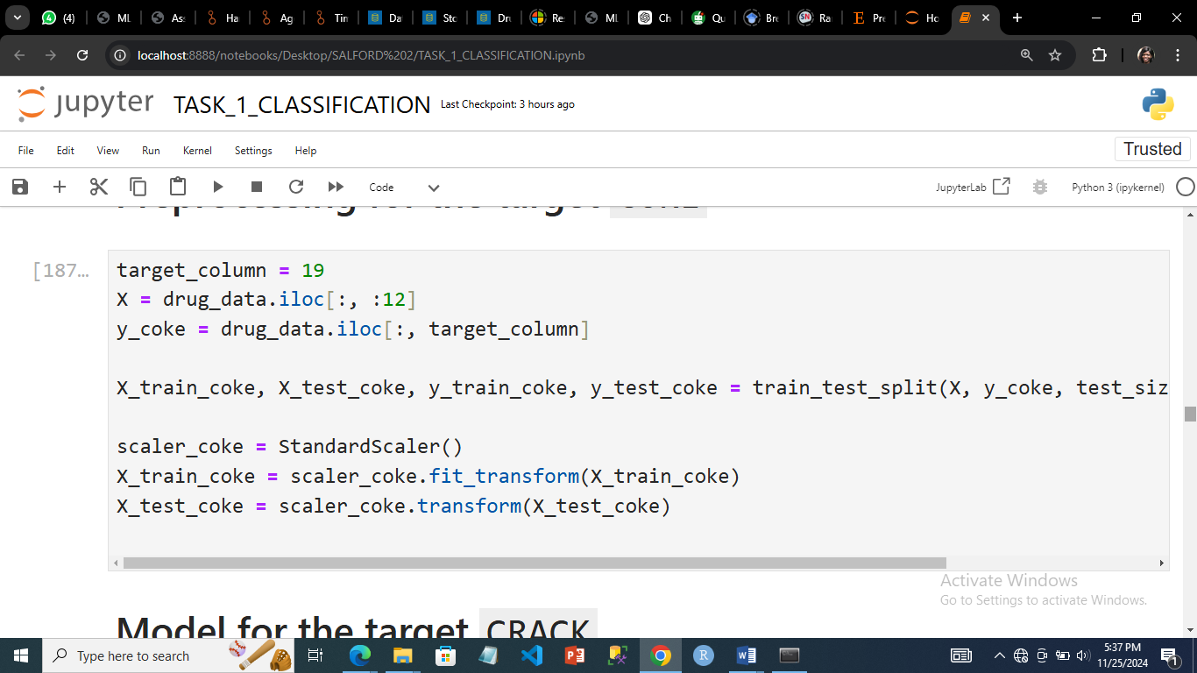

***Data processing and feature scaling for the target COKE***

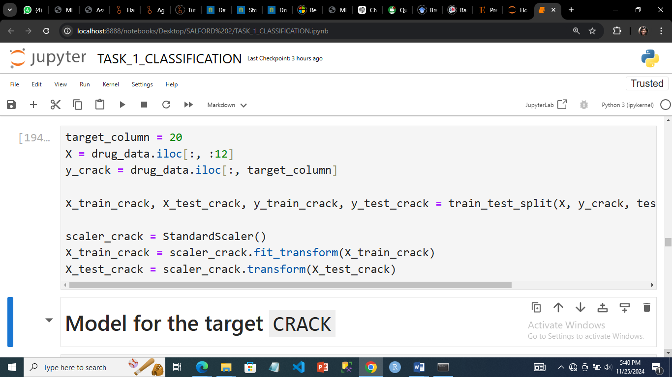

***Data processing and feature scaling for the target CRACK***

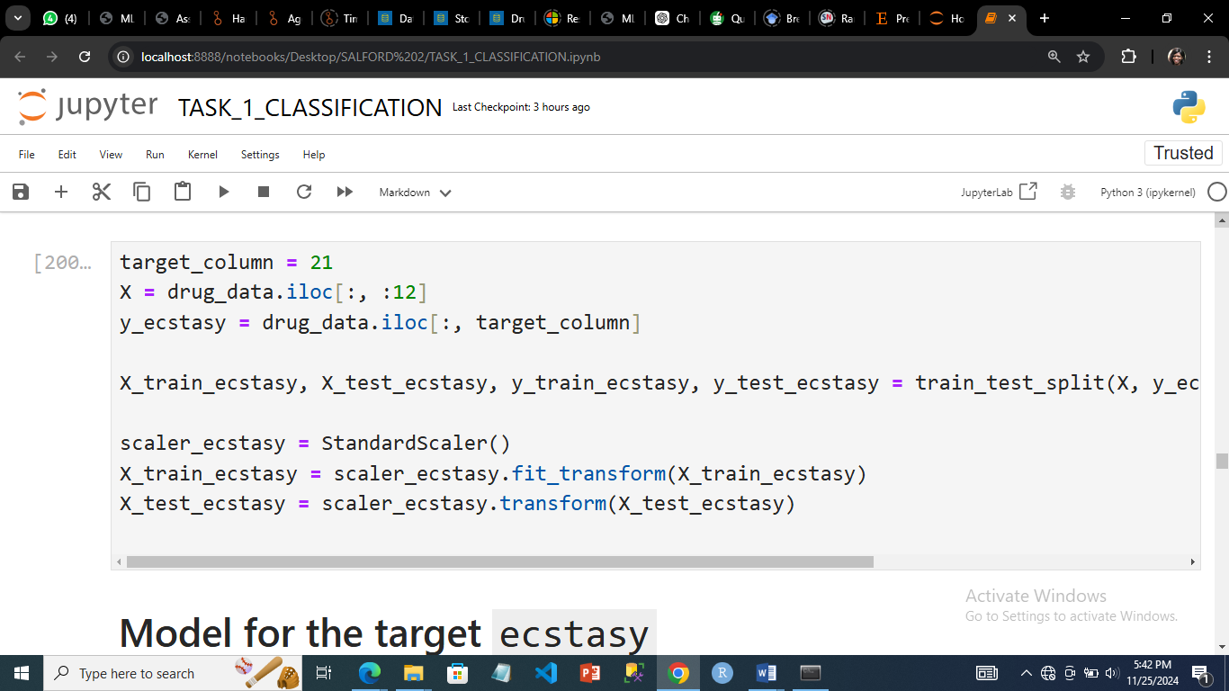

***Data processing and feature scaling for the target ECSTACY***

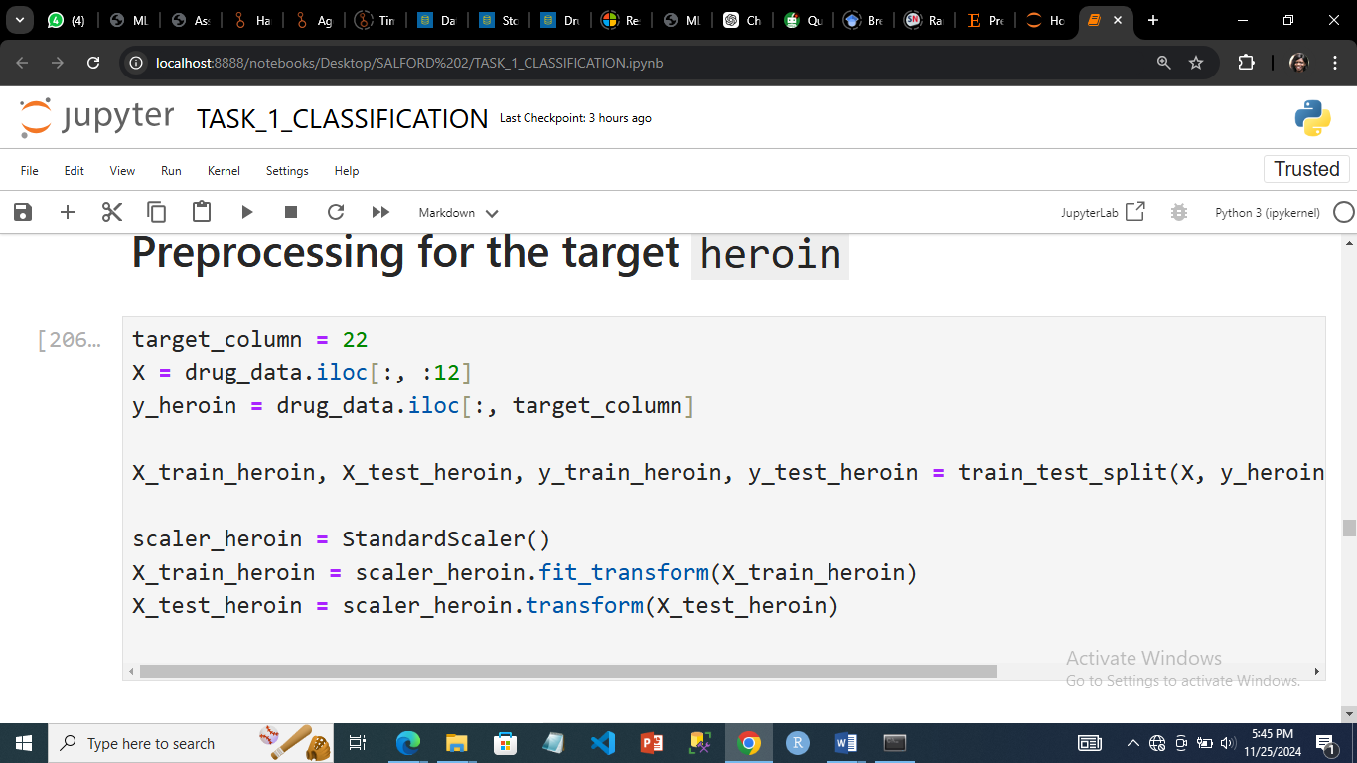

***Data processing and feature scaling for the target HEROIN***

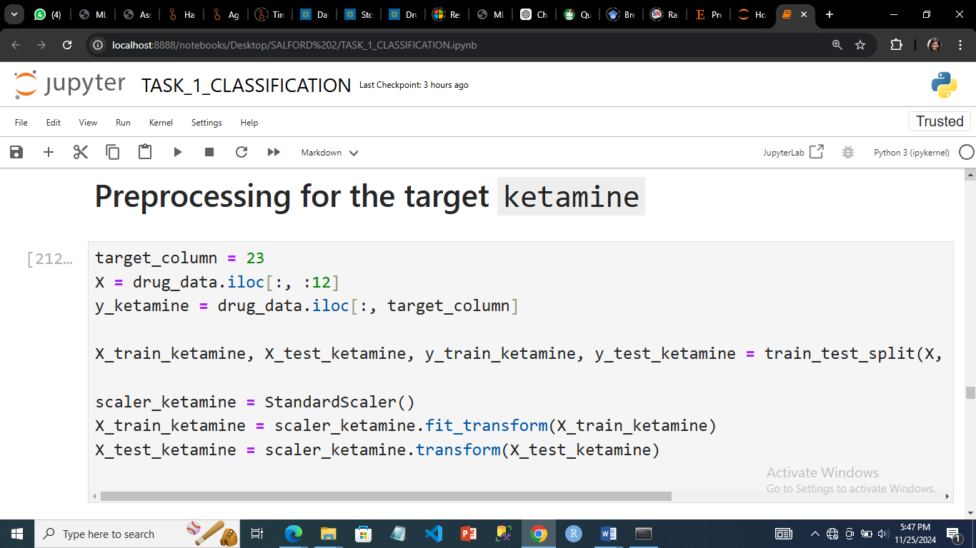

***Data processing and feature scaling for the target KETAMINE***

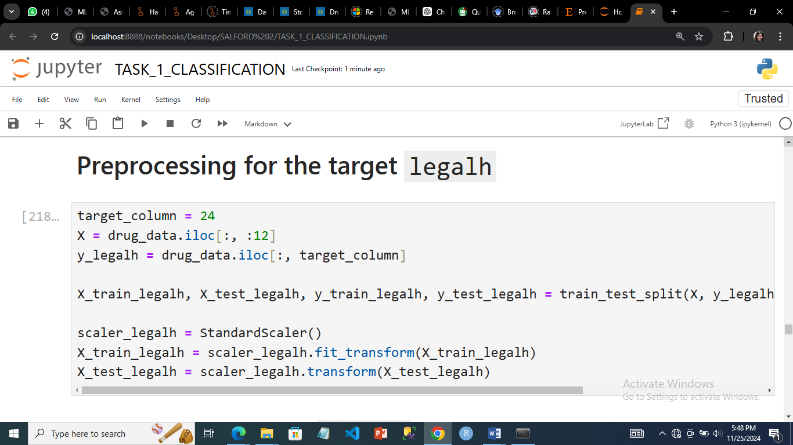

***Data processing and feature scaling for the target LEGALH***

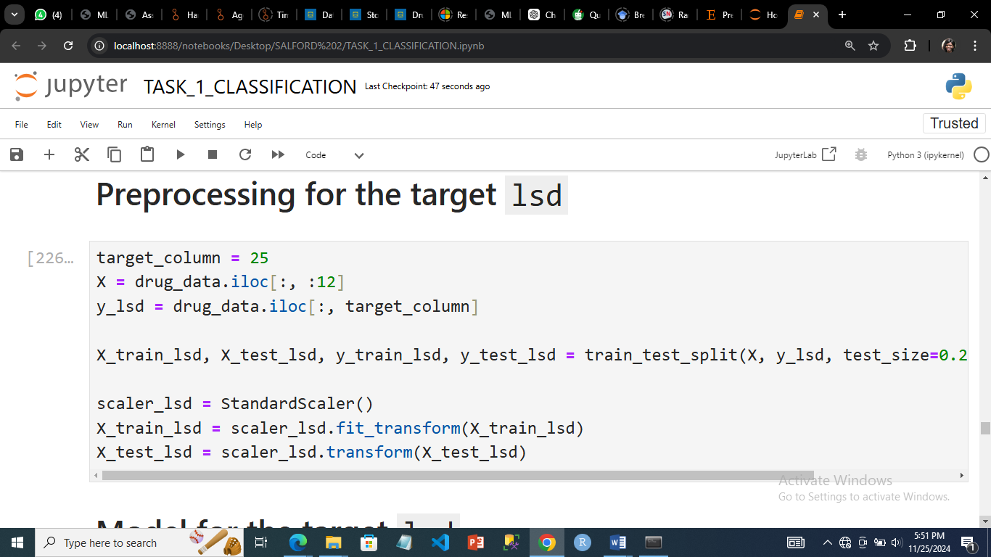

***Data processing and feature scaling for the target LSD***

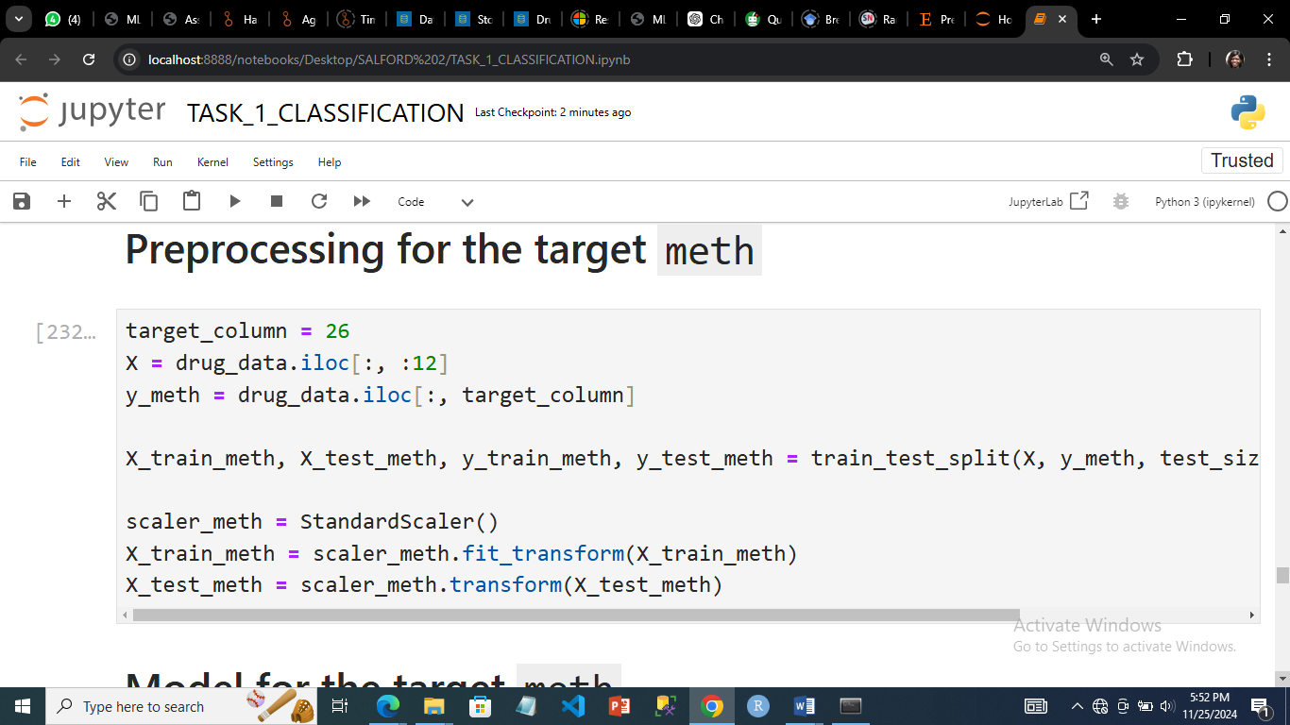

***Data processing and feature scaling for the target METH***

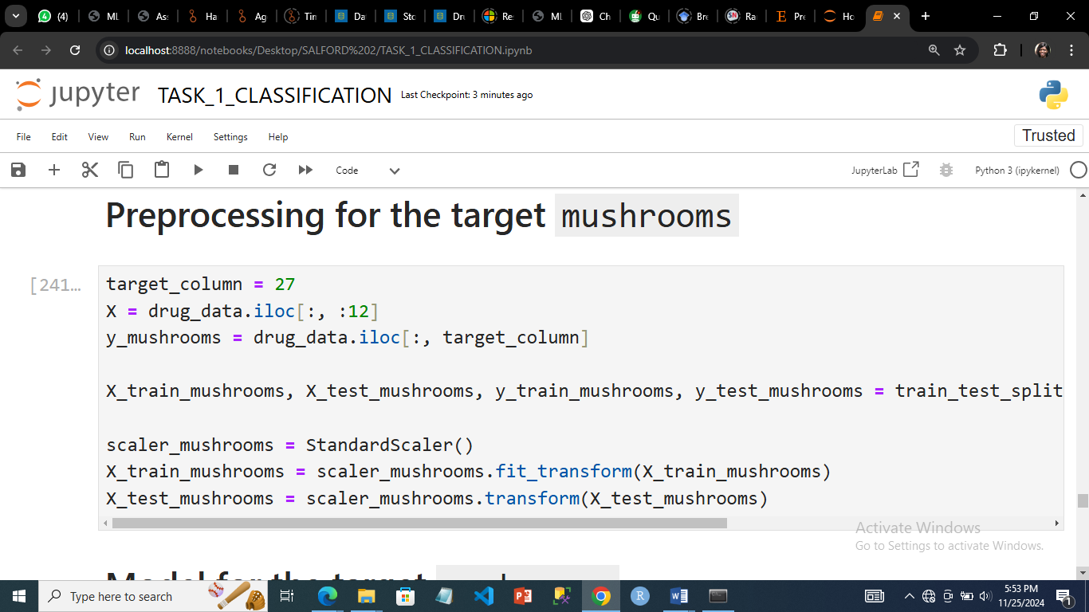

***Data processing and feature scaling for the target MUSHROOM***

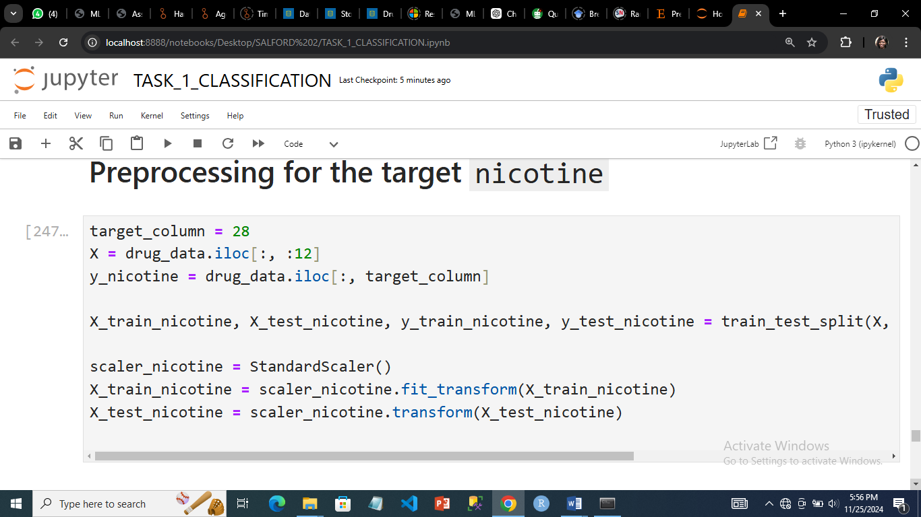

***Data processing and feature scaling for the target NICOTINE***

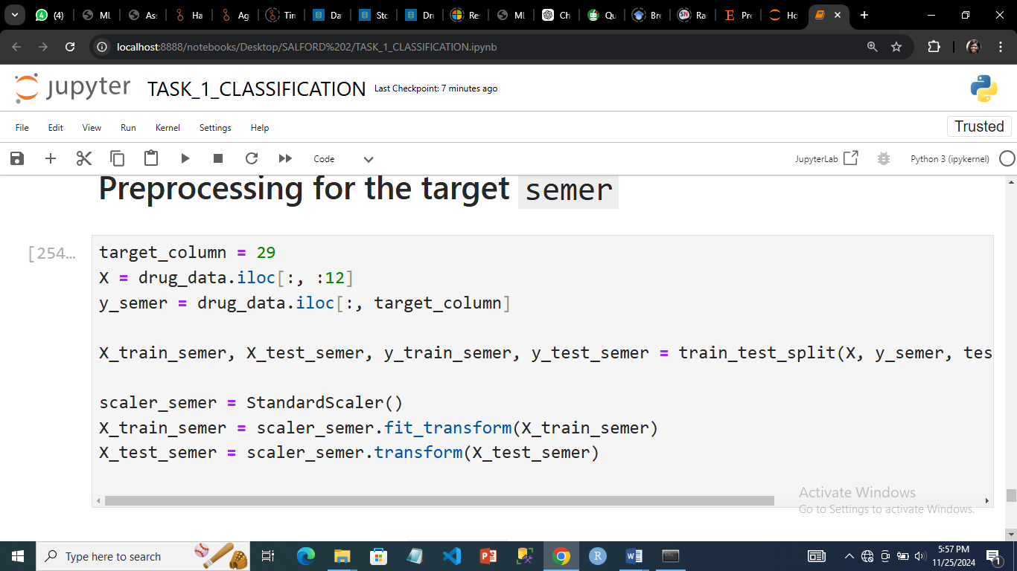

***Data processing and feature scaling for the target SEMER***

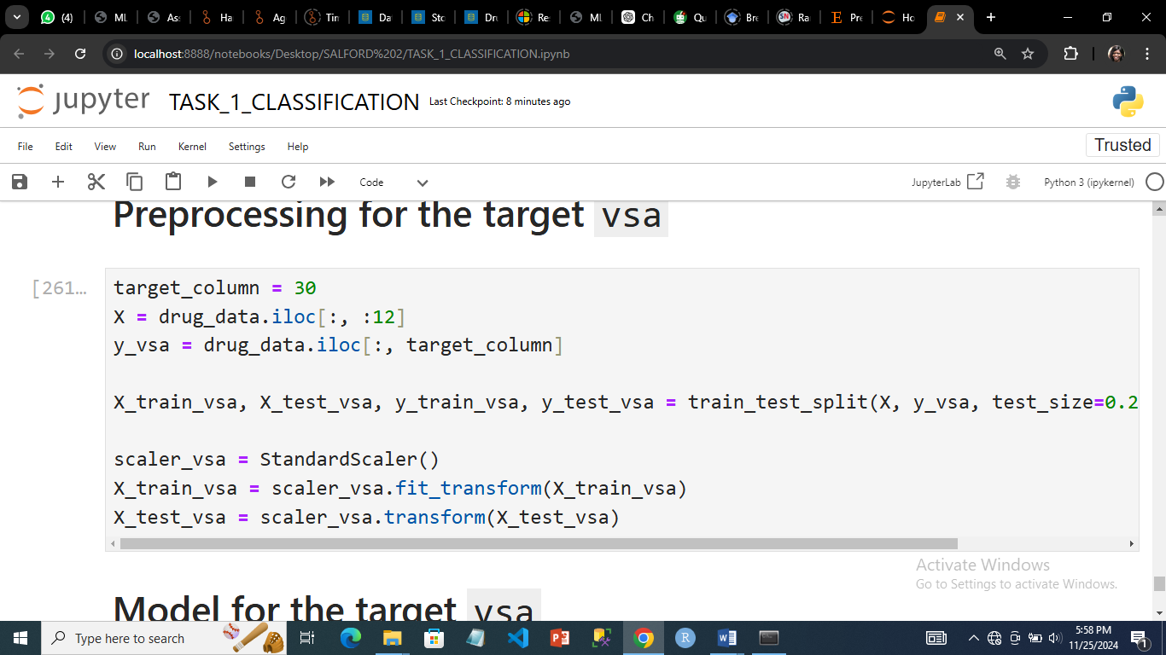

***Data processing and feature scaling for the target VSA***

## 4.0 Targets with their classification algorithms

Two classification algorithms, Random Forest and Support Vector Machines, were applied to the preprocessed dataset. Random Forest was chosen for this analysis because it is robust to overfitting and works well with datasets containing mixed feature types (Hosmer,2000).

Support Vector Machine (SVM) was chosen because of its strength lies in its ability to handle non-linear separable data effectively and has kernel transformations. The RBF kernel ensures flexibility in identifying intricate patterns (Sisodia, 2018).

### 4.1 Alcohol

For the target alcohol, the accuracy for the Random Forest Classifier model was 0.3660 while the SVM Classifier Accuracy was 0.4058. The Random Forest classifier demonstrated considerable performance variations between classes. While it does quite well in CL5, it fails in others, notably CL0, CL1, and CL2.

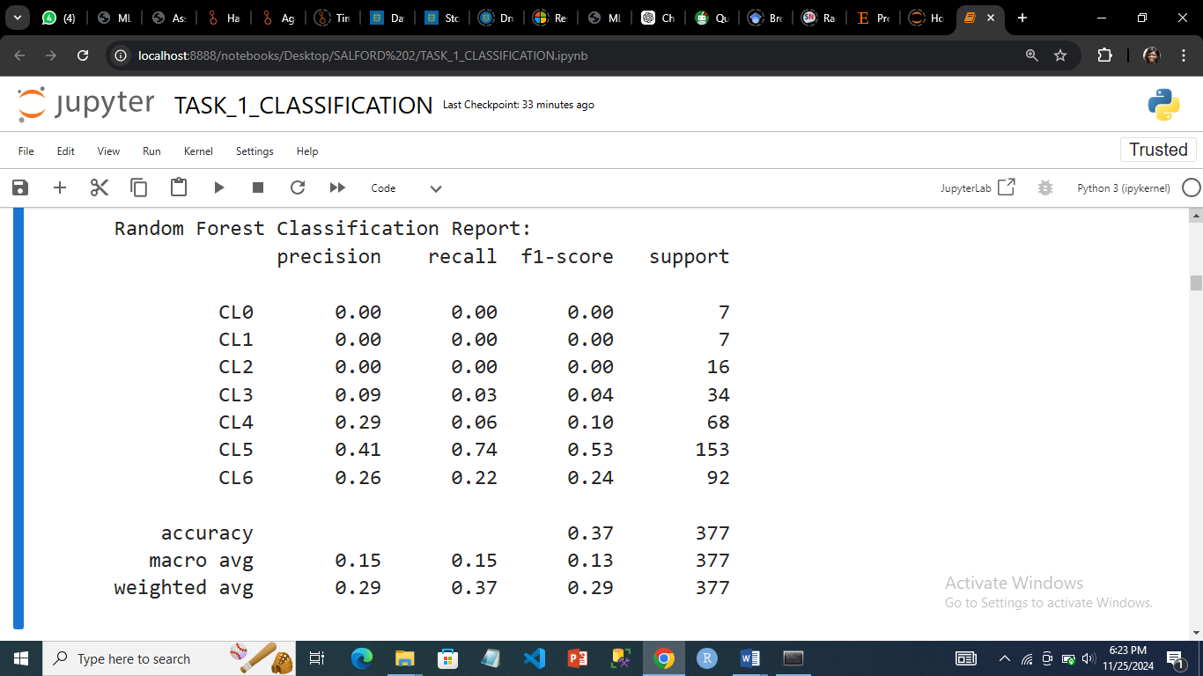

When compared to Random Forest, the SVM classifier had a significantly higher accuracy (0.41 vs. 0.37) and a higher recall for CL5 (0.87 vs. 0.74). However, it did badly in the other classifications, much like the Random Forest classifier.

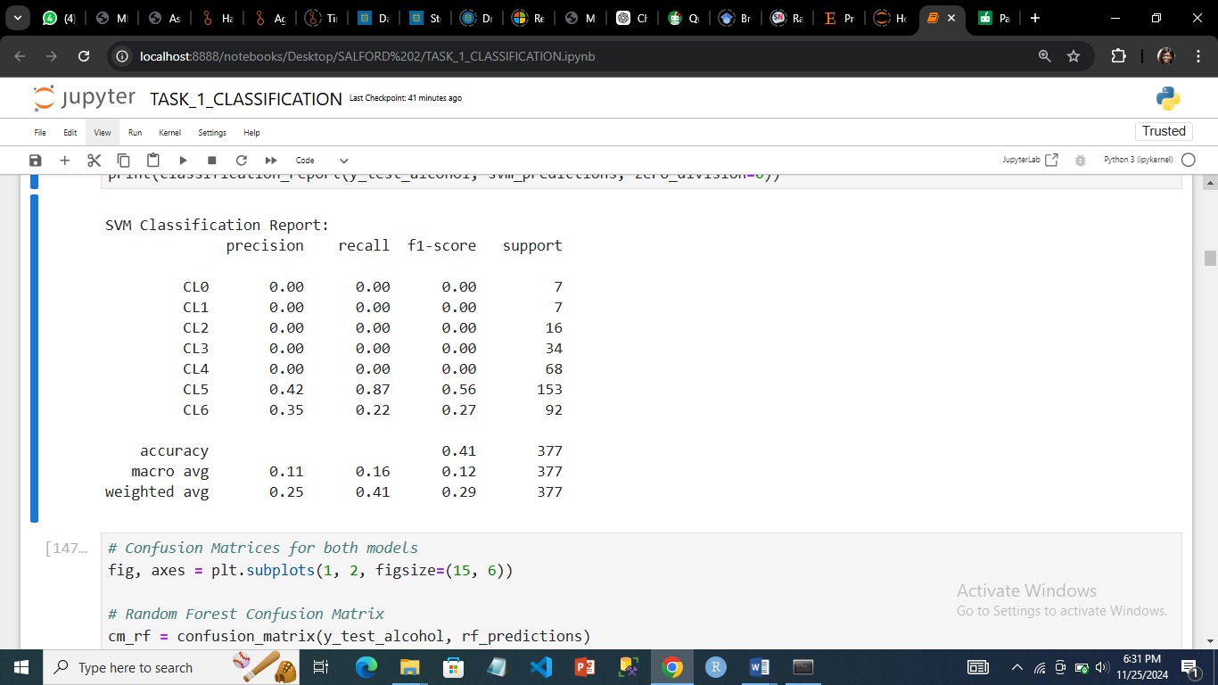

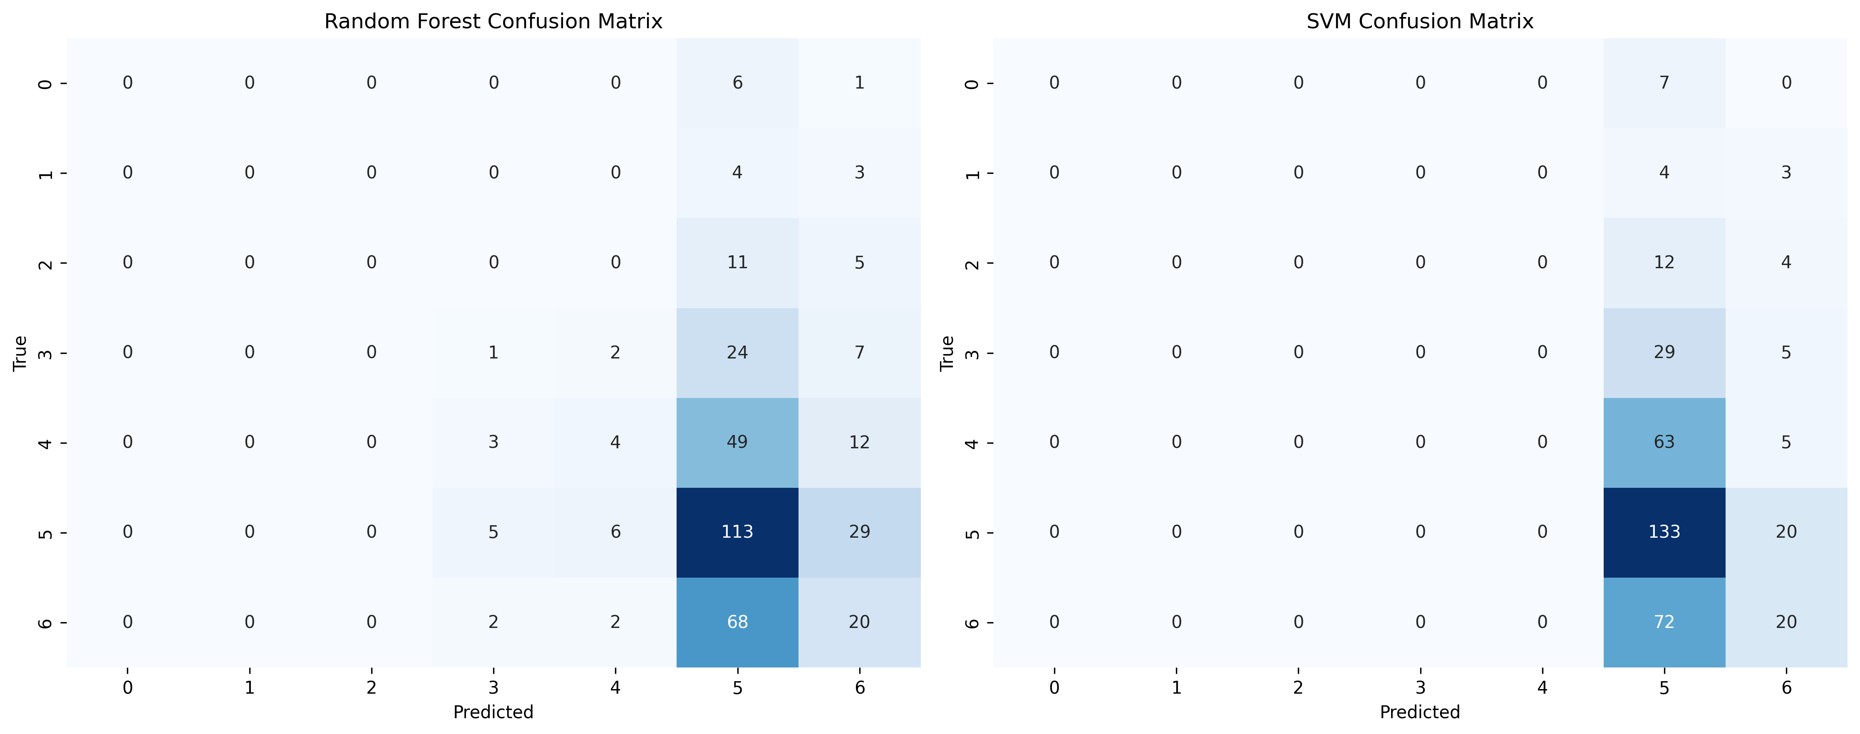

*Heatmap showing the confusion matrix of both models*

### 4.2 Amphet

The accuracy of the Random Forest Classifier model and the SVM Classifier for the target classification test were 0.5100. The Random Forest classifier showed significant performance variability between classes. While it performed in CL0, with an accuracy of 0.58 and a recall of 0.90, it struggles substantially in minority classes like CL4, CL5, and CL6, where the metrics are frequently zero.

The SVM Classifier showed class-wise differences. It performed well in CL0 with a precision of 0.55 and a recall of 0.95, but it failed to forecast instances from minority classes such as CL2, CL4, CL5, and CL6, returning zero results across all measures. For CL1 and CL3, the SVM had poor recall values of 0.02 and 0.14, indicating difficulties detecting these classes.

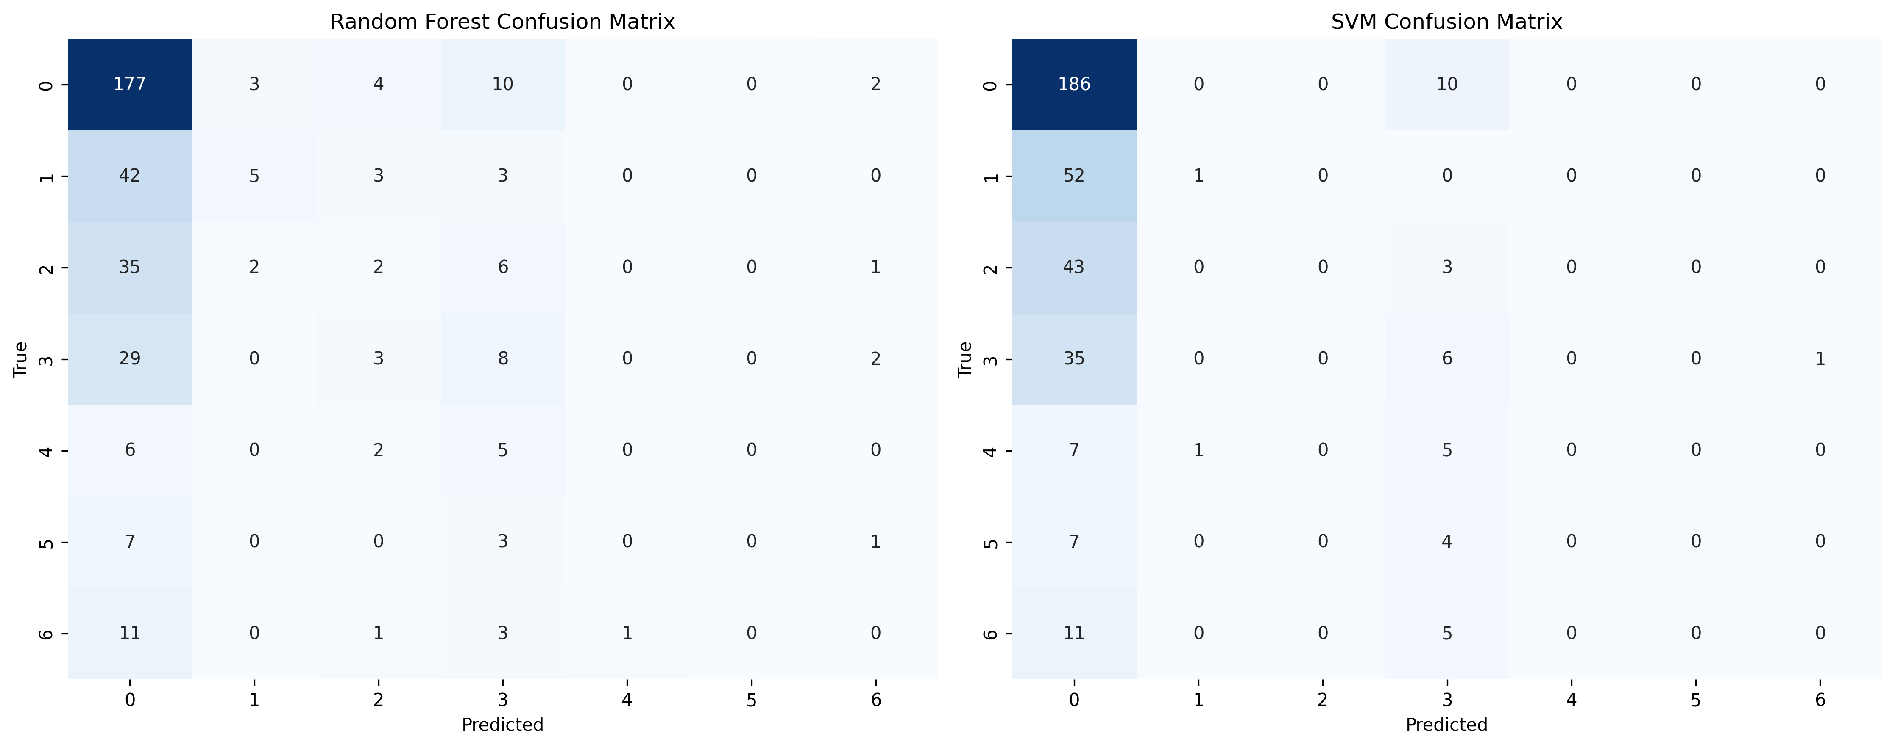

### 4.3 Amyl

The Random Forest Classifier model had an accuracy of 0.7000 on the target classification job, whereas the SVM Classifier had an accuracy of 0.6900. The Random Forest classifier showed notable performance variability across classes. It performed well in the majority class, CL0, with an accuracy of 0.71 and recall of 0.97. However, it performed poorly in minority classes, with CL1 having a recall of 0.13 and CL2, CL3, CL4, and CL5 all having very low or zero recall and accuracy scores. This demonstrated the model's difficulties in accurately forecasting minority classes.

The SVM classifier performed well on CL0, with a precision of 0.69 and a perfect recall of 1.00. However, it did not generalize to other classes. CL1 had a perfect accuracy of 1.00 but a recall of only 0.02, indicating that it seldom recognized actual CL1 cases. Minority classes such as CL2, CL3, CL4, and CL5 obtain zero ratings on all measures

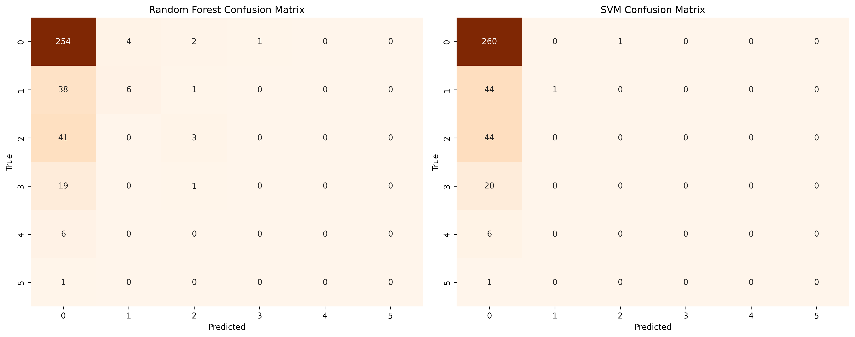

### 4.4 Benzos

The Random Forest Classifier model and the SVM Classifier obtained 0.5500 accuracy for the target classification. The Random Forest classifier showed diversity in performance across classes. It did well for the majority class, CL0, with a precision of 0.60 and a recall of 0.95, showing high classification of this class. However, the model failed with minority classes such as CL1, CL2, CL4, CL5, and CL6, returning low or zero scores across all measures. For example, CL5 had a precision, recall, and F1-score of 0.00, indicating that the model was unable to predict this class successfully.

The SVM classifier also relied significantly on the majority class, CL0, achieving a precision of 0.56 and a recall of 1.00. In other classes, its performance was substantially lower. CL1, CL4, CL5, and CL6 had 0 accuracy, recall, and F1-scores, indicating that these classes were not predicted correctly. For CL3 and CL2, the SVM performed significantly better, with CL3 reaching a precision of 0.50 but a recall of just 0.06.

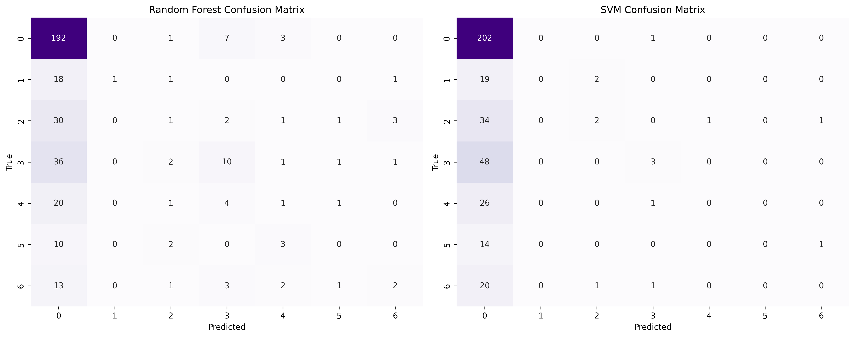

### 4.5 Caff

Both the Random Forest Classifier model and the SVM Classifier obtained an accuracy of 0.73 for the target Caff. For the majority class, CL6, the Random Forest classifier performed well, with an F1-score of 0.84, a precision of 0.73, and a recall of 1.00. All other classes (CL0 through CL5), however, were not predicted by the model; its accuracy, recall, and F1-scores were all zero.

The SVM classifier, which performed exceptionally well in predicting the majority class, CL6, with an F1-score of 0.85, a precision of 0.73, and a recall of 1.00. All metrics (precision, recall, and F1-scores) for CL0 through CL5 were reported as zero, indicating that it was unable to forecast any of the minority classes.

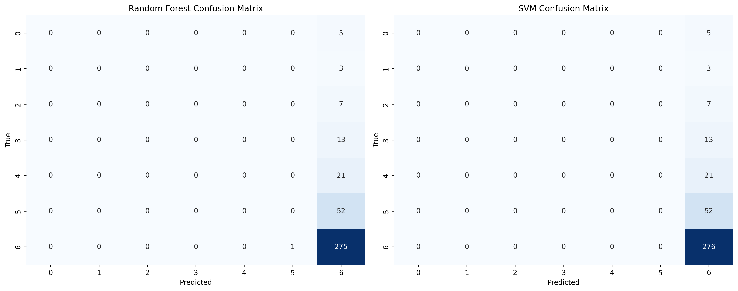

### 4.6 Cannabis

The Random Forest Classifier model's accuracy for the target Cannabis was 0.41, and the SVM Classifier model's accuracy was 0.42. The Random Forest classifier performed differently in each class. With an accuracy of 0.54, recall of 0.71, and F1-score of 0.61, it did rather well for CL0. It produced moderate results for CL6, with an F1-score of 0.55, a precision of 0.43, and a recall of 0.78. The classifier, however, had trouble with the other classes, especially CL4 and CL5, where all measures were close to zero, suggesting subpar prediction ability.

Similar patterns were shown by the SVM classifier, which performed best in CL0 and CL6. It obtained an accuracy of 0.52, a recall of 0.73, and an F1-score of 0.61 for CL0. For CL6, it obtained an F1-score of 0.58, a precision of 0.43, and a recall of 0.88. With 0 scores for accuracy, recall, and F1-score, the model was unable to accurately predict CL3, CL4, and CL5.

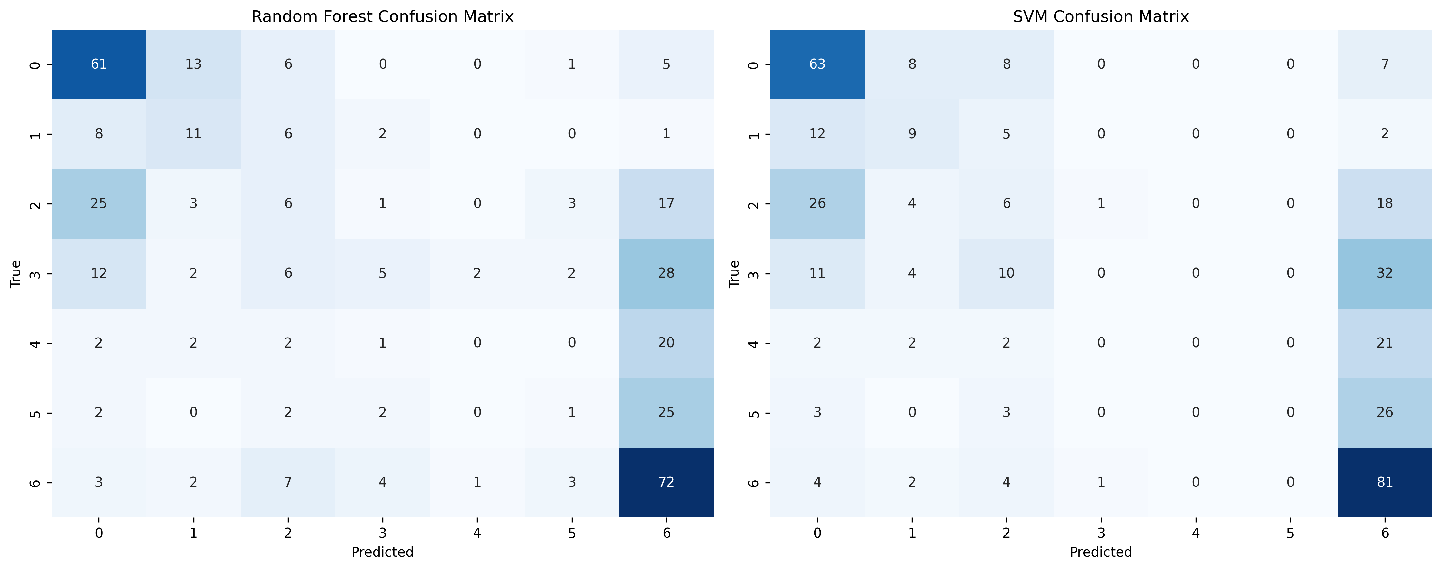

### 4.7 Choc

The Random Forest Classifier model had an accuracy of 0.42 for the target classification test, whereas the SVM Classifier model had an accuracy of 0.41.   
  
Different classes showed different results from the Random Forest classifier. The F1-scores for CL5 and CL6 were 0.38 and 0.51 respectively, indicating a modest level of performance. Its accuracy, recall, and F1-scores were all zero for the other classes, CL0, CL2, and CL3, indicating subpar performance. Minority classes like CL0 and CL3 were very difficult for the classifier to handle, indicating challenges with class imbalance.

With an F1-score of 0.55, a precision of 0.42, and a recall of 0.76, the SVM classifier performed best for CL6. Zero scores for CL0, CL2, and CL3 across all criteria, however, show that it was unable to forecast these classes. With an F1-score of 0.29, the classifier performed quite well for CL5.

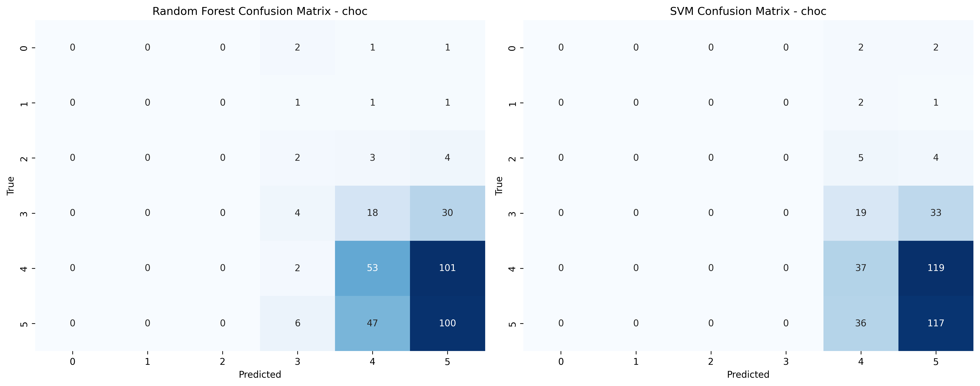

### 4.8 Coke

The accuracy of the Random Forest Classifier was 0.58. With an F1-score of 0.77, an accuracy of 0.66, and a recall of 0.93, it did well for the majority class CL0. The model, however, had trouble with minority classes like CL4, CL5, and CL6, reporting zero F1-scores, accuracy, and recall. With F1-scores of 0.21 and 0.06, respectively, other classes, such as CL1 and CL2, had low recall but reasonable accuracy.   
  
The accuracy of the SVM Classifier was 0.60. With an accuracy of 0.64, recall of 0.98, and F1-score of 0.78, it outperformed the Random Forest model for CL0. With 0 scores on all measures, the model was unable to produce reliable predictions for minority classes CL4, CL5, and CL6. F1-scores for CL1, CL2, and CL3 were 0.26, 0.04, and 0.04 correspondingly, indicating limited performance.

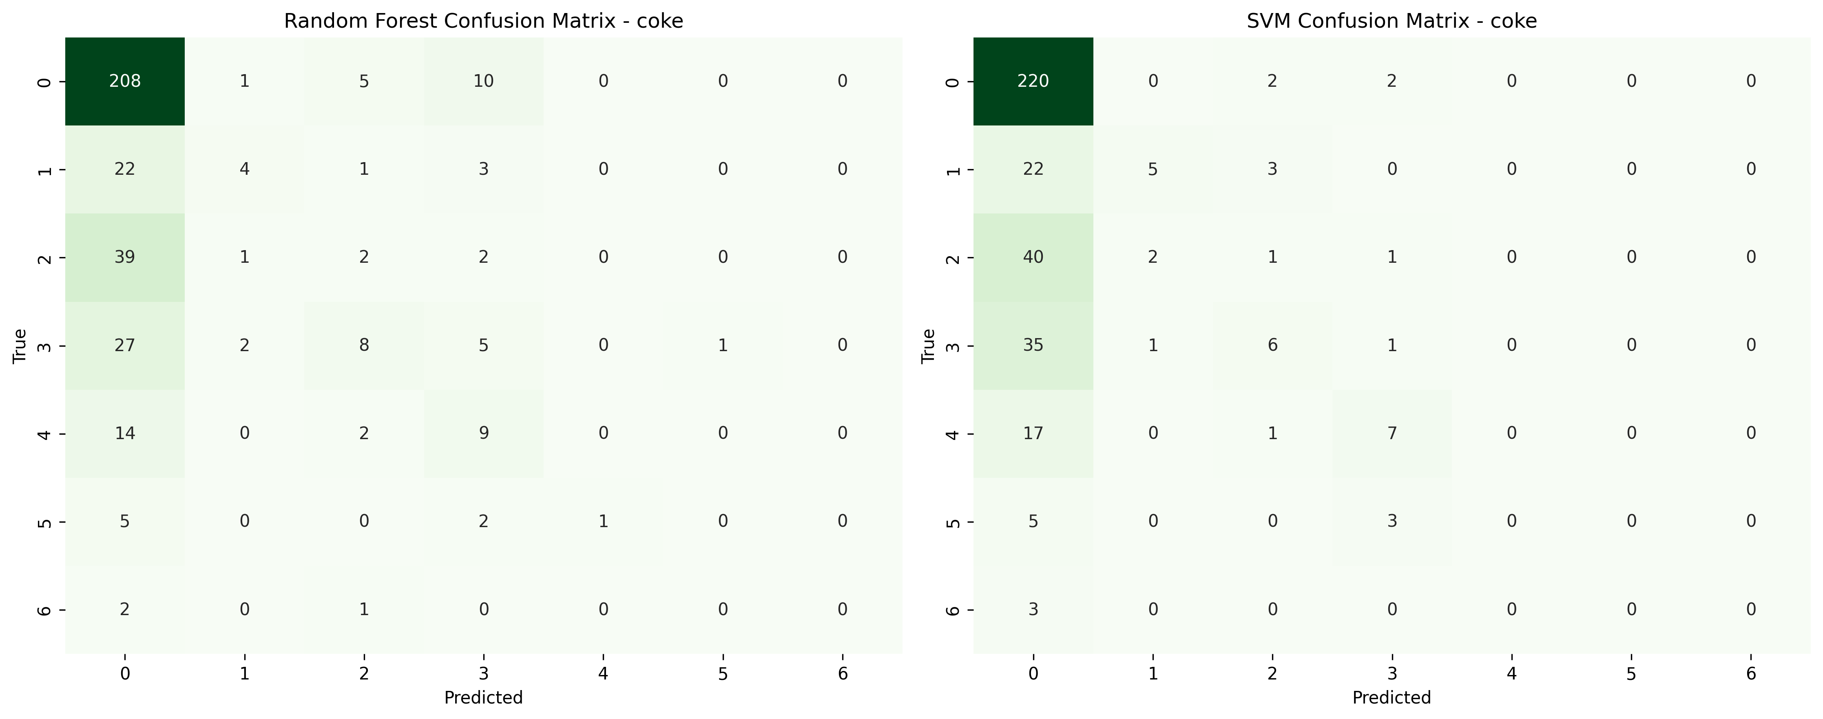

### 4.9 Crack

An overall accuracy of 0.89 was attained with the Random Forest Classifier. F1-score (0.94), recall (1.00), and accuracy (0.89) were all strong for the majority class, CL0. However, with 0 accuracy, recall, and F1-scores, the model had trouble handling minority classes like CL1, CL3, CL4, CL5, and CL6. With an F1-score of 0.09 for CL2, the model reported an accuracy of 1.00 but a relatively poor recall of 0.05. The SVM Classifier's accuracy was 0.89. With an F1-score of 0.94, a precision of 0.89, and a recall of 1.00, it demonstrated remarkable performance for CL0. The classifier generated 0 accuracy, recall, and F1-scores for all other classes (CL1 through CL6), suggesting that it had trouble managing the minority class labels.

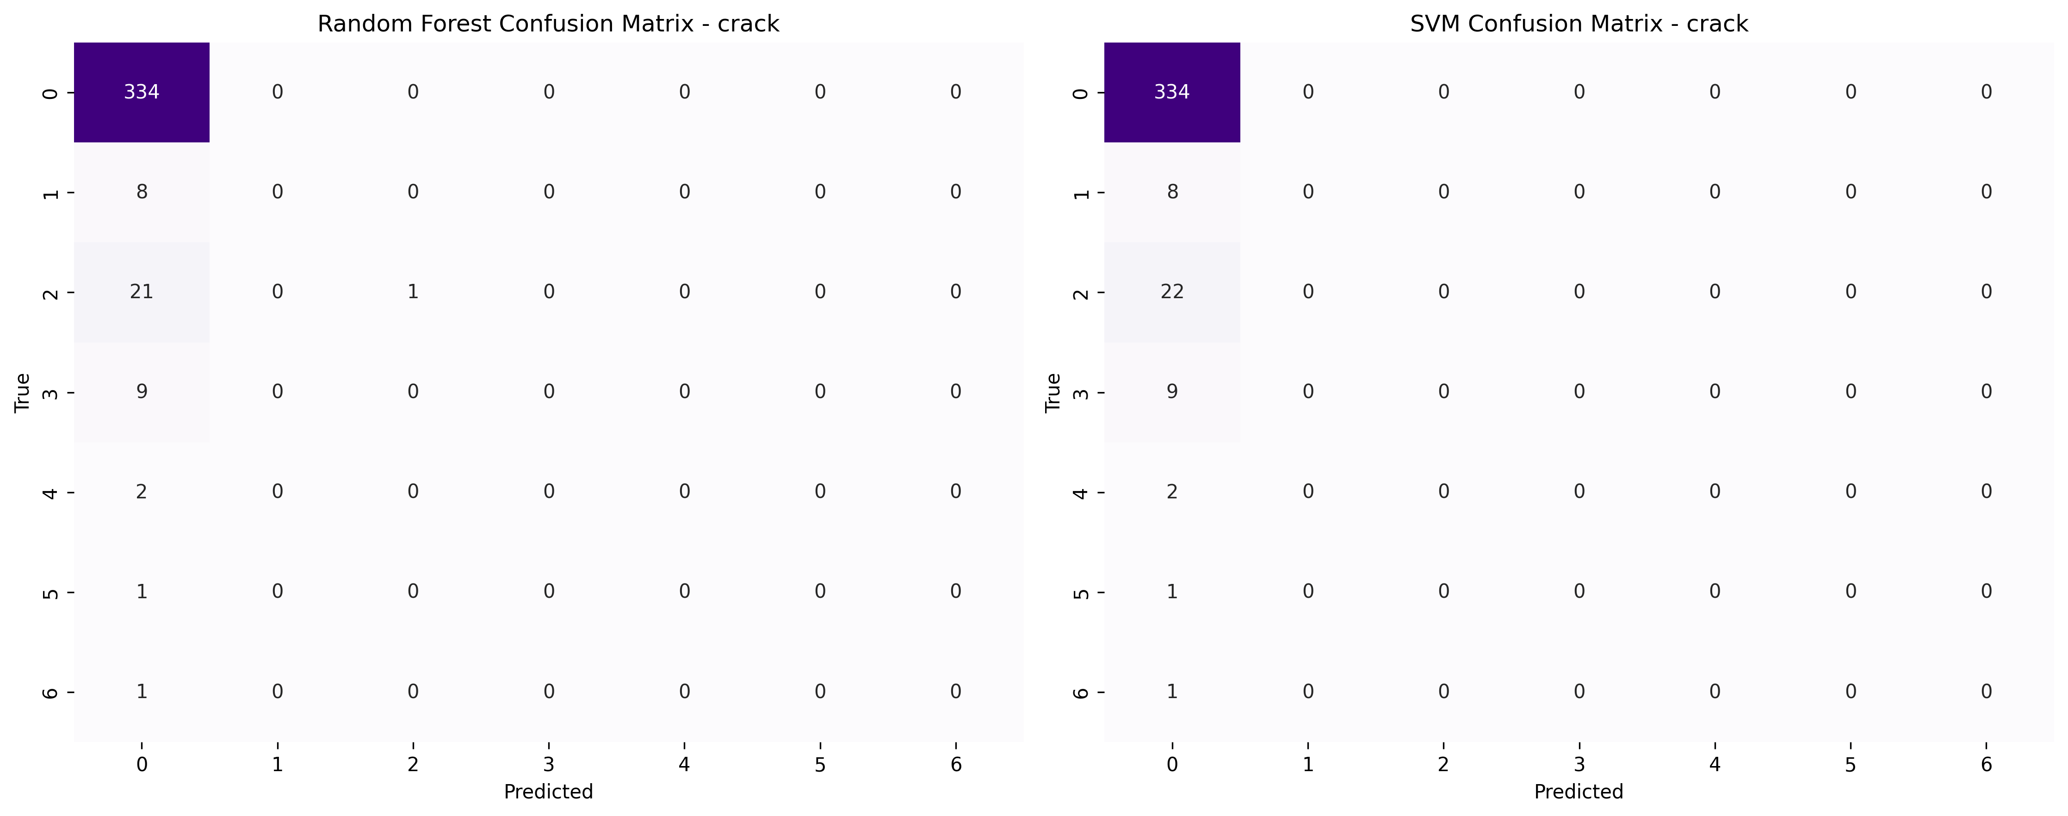

### 4.10 Ecstasy

The Random Forest classifier attained an accuracy of 0.55 on the ecstasy target, with the greatest performance on CL0 (precision: 0.63, recall: 0.88, F1: 0.74). Other courses showed low performance, with F1 values ranging from 0.00 to 0.33.

The SVM classifier had an accuracy of 0.56 and performed well on CL0 (precision: 0.59, recall: 0.92, F1: 0.72) but struggled with minority classes, which had near-zero metrics. Both models did well on CL0 but struggled to predict minority classes well.

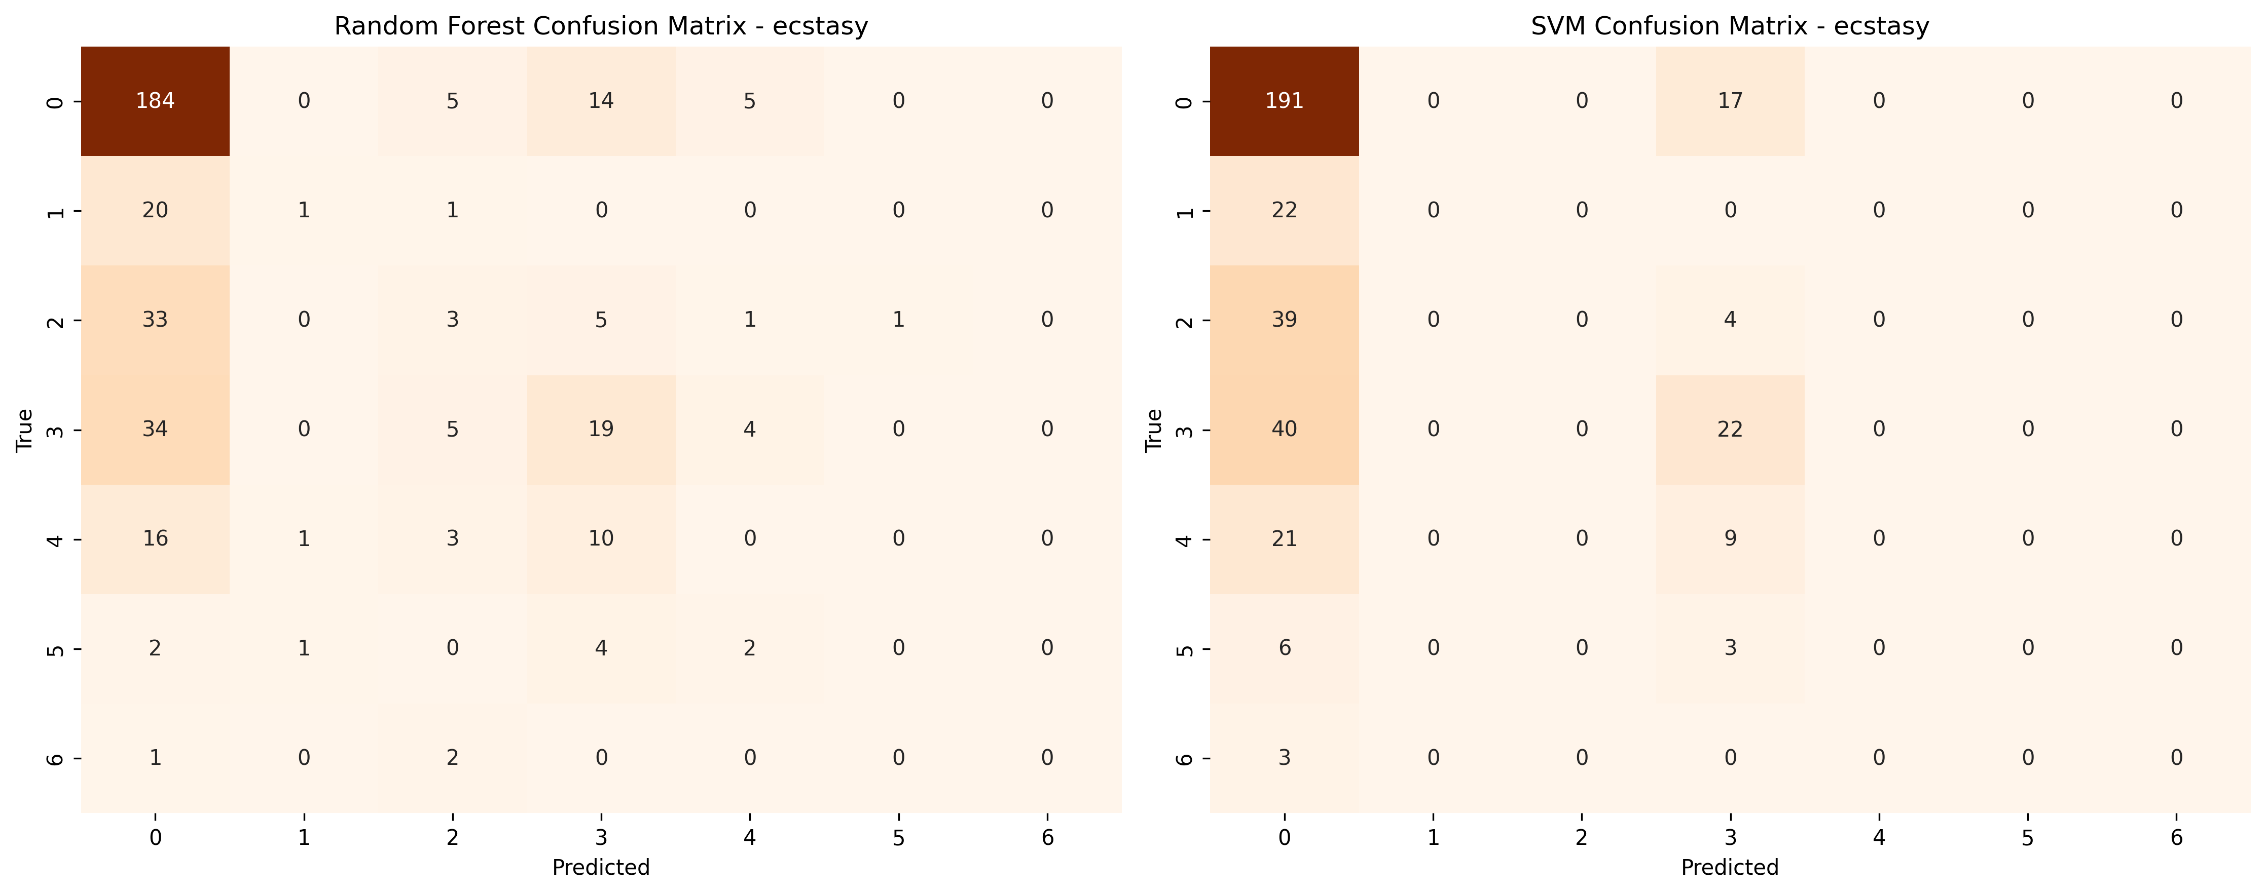

### 4.11 Heroin

The Random Forest classifier attained an accuracy of 0.86, excelling at identifying CL0 (precision: 0.86, recall: 1.00, F1: 0.92). Other courses were poorly predicted, with F1 values close to zero. The SVM classifier likewise attained an accuracy of 0.86, showing great performance on CL0 but failing to forecast minority classes successfully. Both models strongly predicted the majority class (CL0).

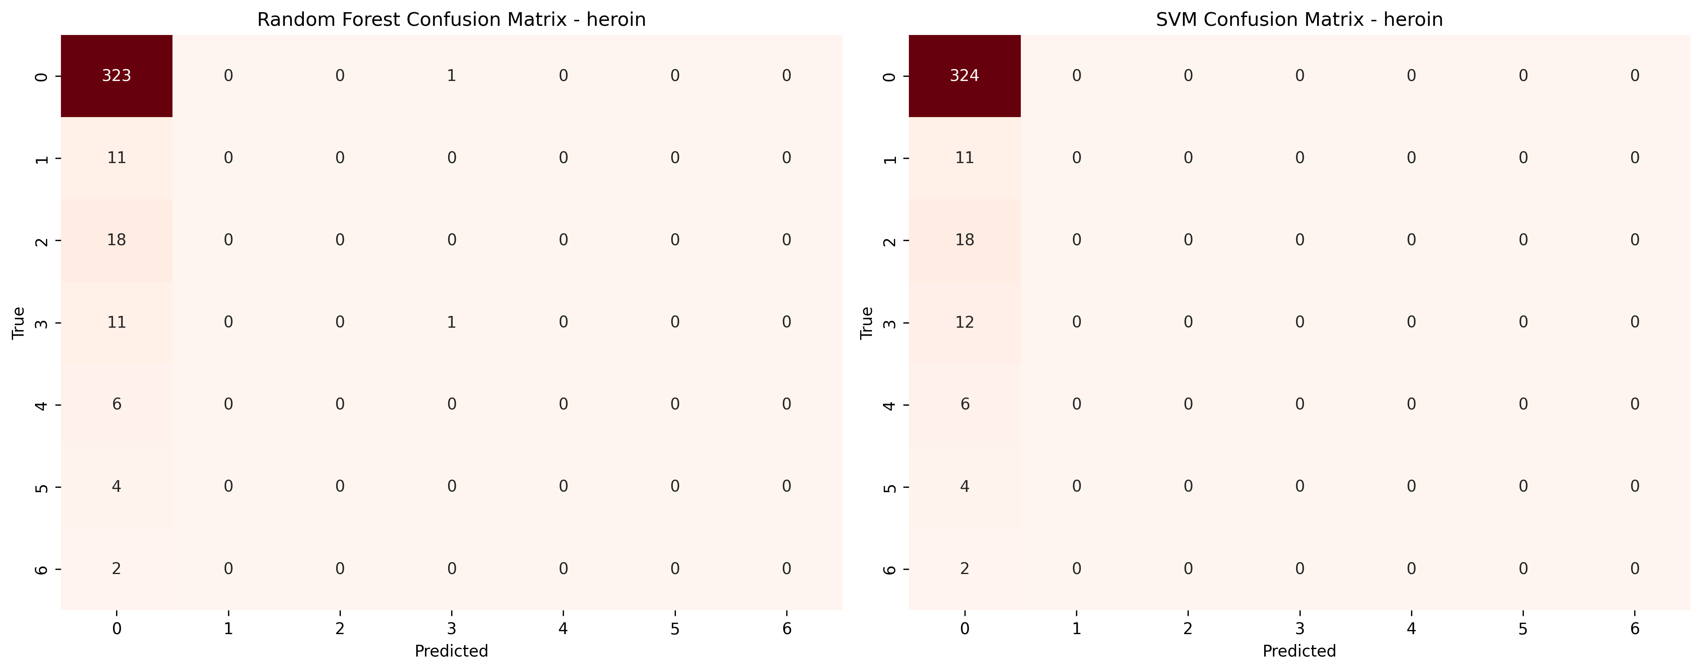

### 4.12 Ketamine

The Random Forest and SVM classifiers both have an accuracy of 0.82. Both models performed well in the majority class (CL0), with accuracy, recall, and F1-score values of 0.82, 1.00, and 0.90, respectively. However, they failed with minority classes, failing to generate significant predictions for CL1–CL6, resulting in F1-scores of 0. The weighted averages for both models were comparable, emphasizing the disparity in performance between classes.

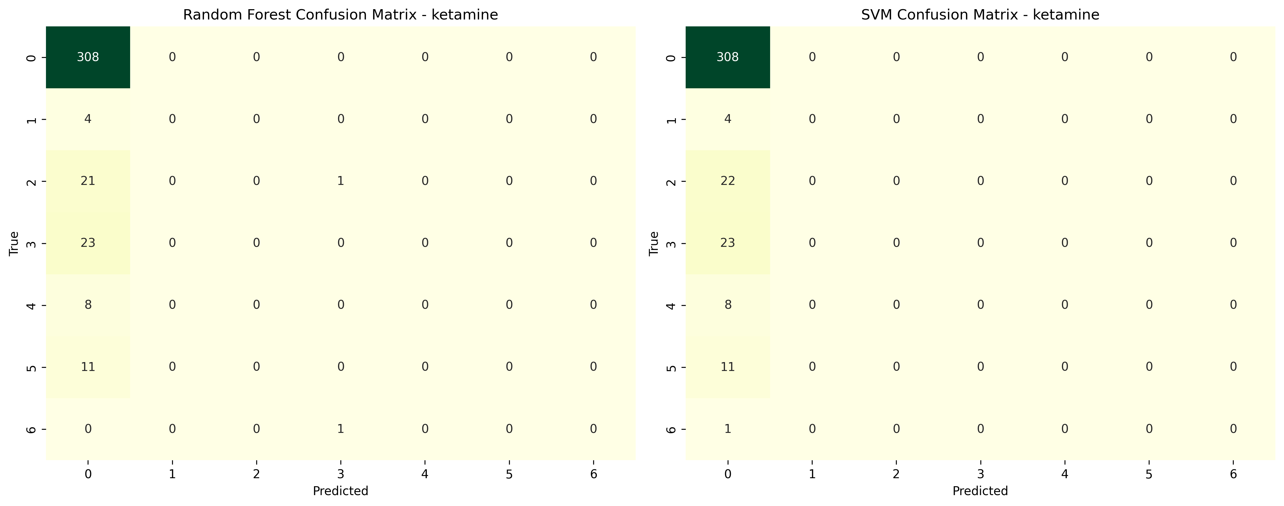

### 4.13 Legalh

The accuracy of the Random Forest model for the "legalh" classification was 0.60. With an F1-score of 0.81, a precision of 0.72, and a recall of 0.93, it excelled on class CL0. But the model had trouble with the minority classes, especially CL1, CL2, CL4, CL5, and CL6, where its accuracy and recall were subpar. The overall poor balance among classes was shown by the macro-average F1-score of 0.19, however the weighted average F1-score of 0.54 indicated improved performance on the majority class.

Despite having a little better accuracy of 0.61, the SVM model had comparable performance traits. It performed well for CL0, with an F1-score of 0.80, recall of 0.93, and accuracy of 0.70, similar to Random Forest. There were no significant forecasts for CL1, CL2, CL4, CL5, and CL6, indicating poor performance for the minority groups once more. The SVM model showed the same performance imbalance, with a weighted average F1-score of 0.53 and a macro-average F1-score of 0.17. Although both models performed well in classifying the majority class, they had serious problems with the minority classes.

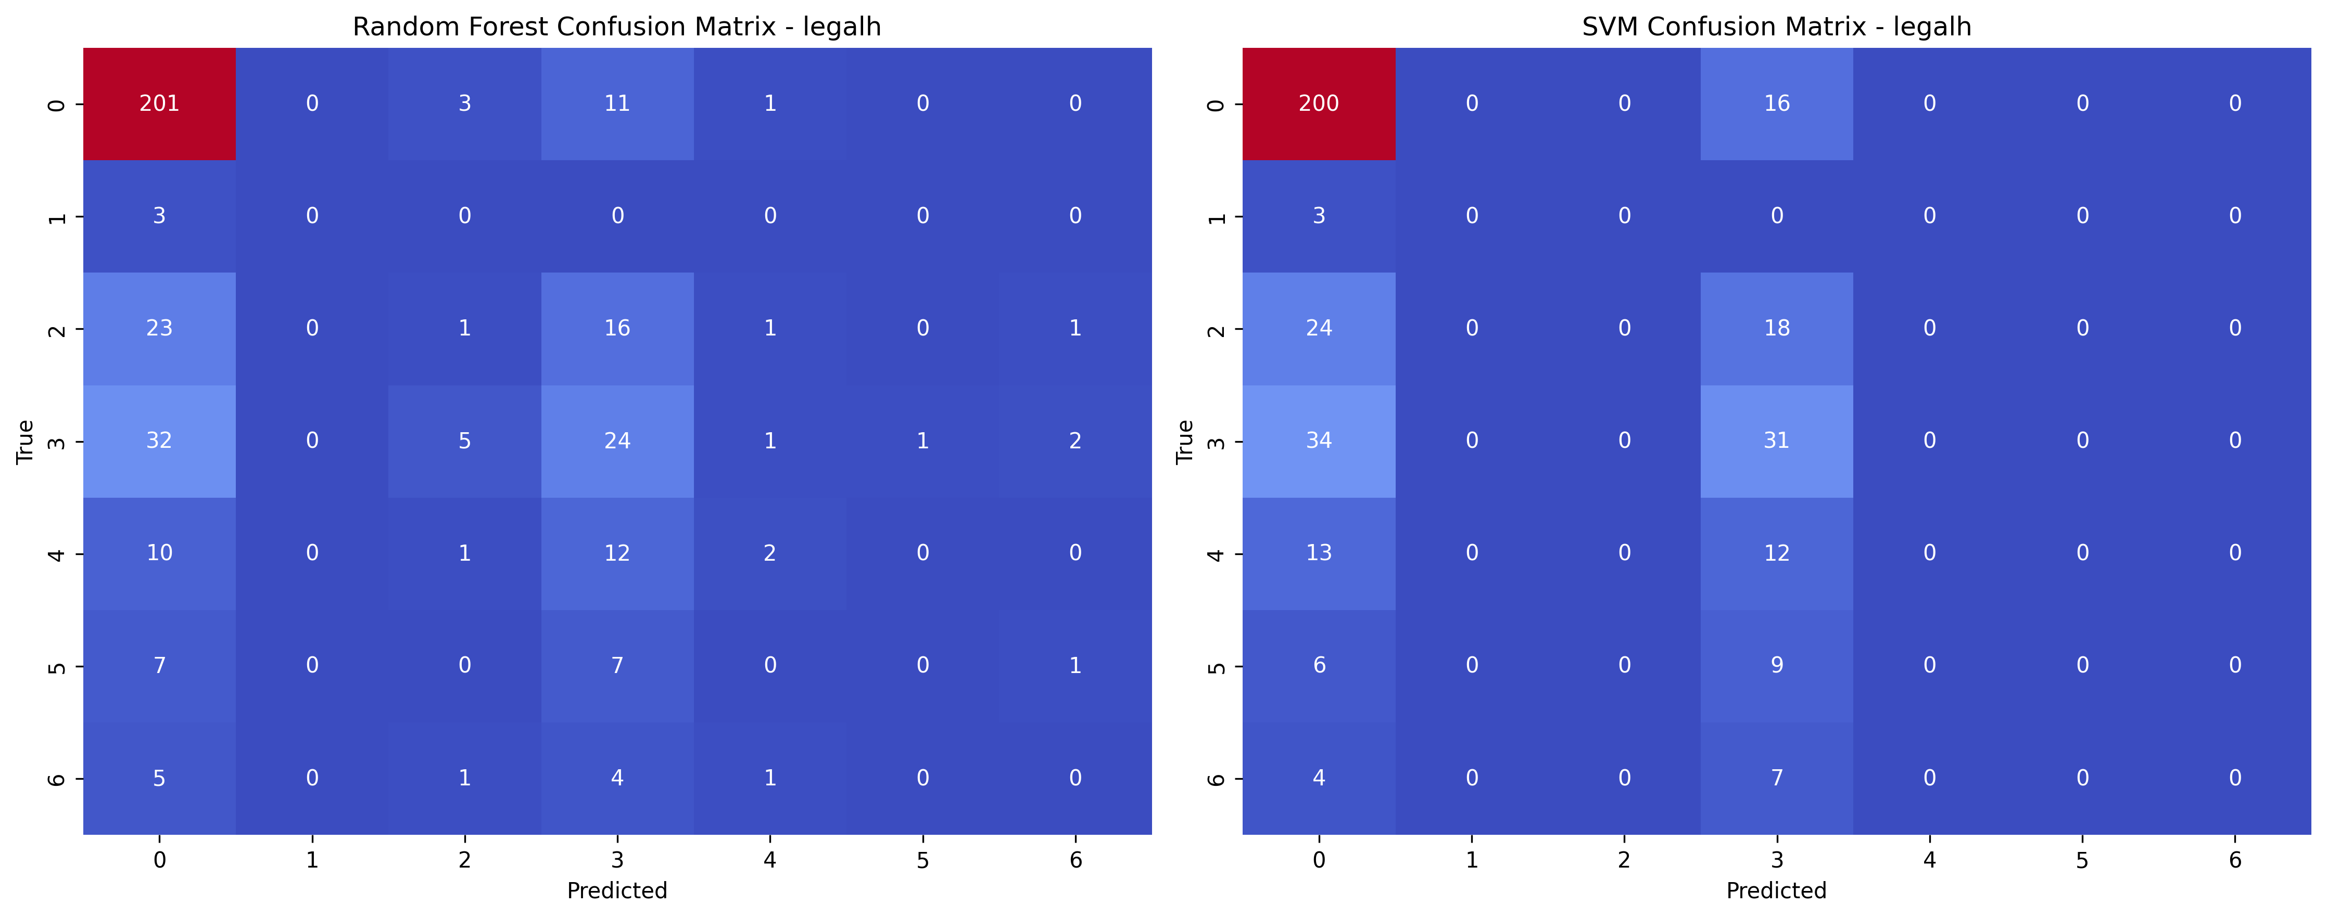

### 4.14 LSD

The Random Forest model's accuracy for the LSD classification challenge was 0.60. With an accuracy of 0.67, recall of 0.89, and F1-score of 0.76, the model demonstrated strong performance on CL0. Nevertheless, it had trouble with the minority classes, performing extremely poorly in CL1, CL2, CL3, CL4, CL5, and CL6. The weighted average F1-score was 0.54, suggesting superior performance on the majority class, but the macro-average F1-score was 0.23, showing poor performance across all classes. At 0.61 accuracy, the SVM model performed marginally better than the Random Forest model. It demonstrated good performance for CL0, with an F1-score of 0.76, recall of 0.90, and accuracy of 0.66. The minority classes, especially CL1, CL2, CL4, CL5, and CL6, presented difficulties for it, same like with the Random Forest model. The disparity in performance between the majority and minority classes was highlighted by the weighted average F1-score of 0.54 and the macro-average F1-score of 0.23, which were comparable to the Random Forest findings.

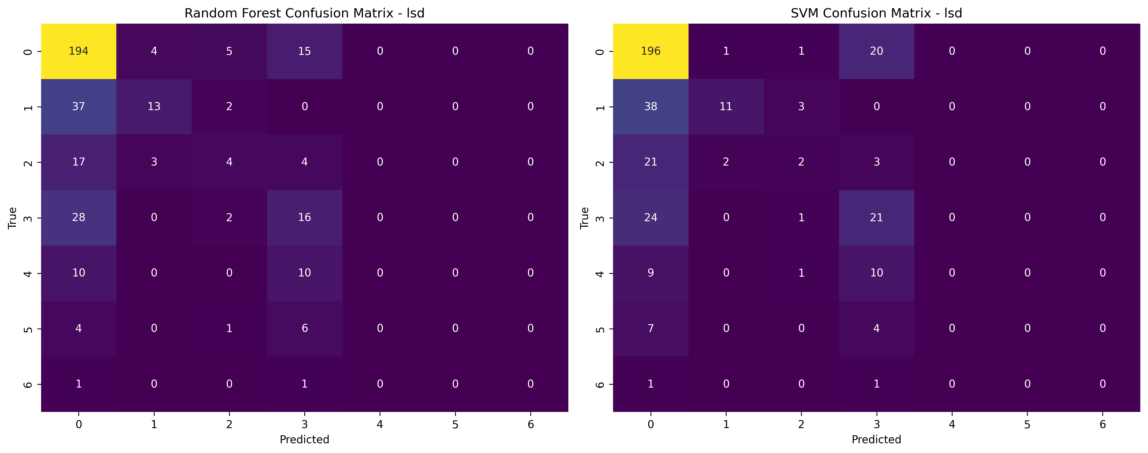

### 4.15 Meth

The Random Forest model's accuracy for the "meth" classification challenge was 0.73. With an accuracy of 0.77, recall of 0.97, and F1-score of 0.86, the model demonstrated good performance on CL0. But it has a lot of trouble with the minority classes, with very poor recall and precision for CL1, CL2, CL3, CL4, CL5, and CL6. The weighted average F1-score was 0.65, demonstrating better performance on the majority class, whereas the macro-average F1-score was 0.15, highlighting the disparity in classification performance.

The accuracy of for the SVM model was 0.75. With an accuracy of 0.75, recall of 1.00, and F1-score of 0.86, it also demonstrated strong performance for CL0. SVM performed almost zero for CL1, CL2, CL3, CL4, CL5, and CL6, much like the Random Forest model did when it came to the minority classes. A comparable disparity in performance between the majority and minority groups was indicated by the weighted average F1-score of 0.65 and the macro-average F1-score of 0.12.

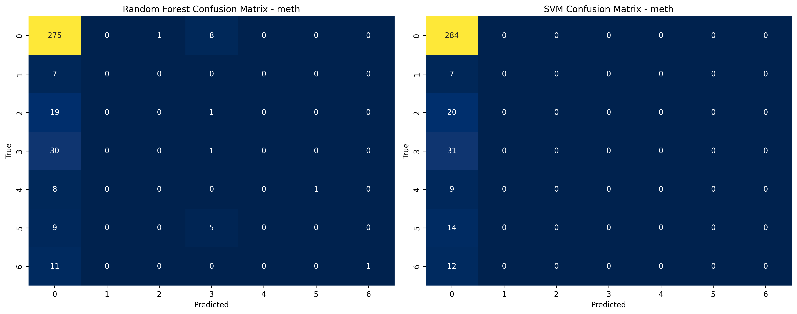

### 4.16 Mushrooms

The Random Forest model's accuracy for the "mushrooms" classification challenge was 0.51. With an accuracy of 0.60, recall of 0.84, and F1-score of 0.70, the model's performance was greatest on CL0. The model, however, had trouble with the minority classes, especially CL1, CL2, CL4, CL5, and CL6, which all had extremely poor accuracy and recall; CL5 and CL6 performed completely poorly. The weighted average F1-score was 0.44, which reflected the better performance on the majority class, however the macro-average F1-score was 0.19, which indicated low performance across all classes.

With an accuracy of 0.52 the SVM model performed similarly. With an accuracy of 0.59, recall of 0.86, and F1-score of 0.70, SVM outperformed the Random Forest model on CL0. With accuracy and recall for CL1, CL2, CL4, CL5, and CL6 around zero, the performance for minority classes was even worse than Random Forest's. The majority class performed better and showed an overall comparable imbalance, as seen by the weighted average F1-score of 0.43 and the macro-average F1-score of 0.18.

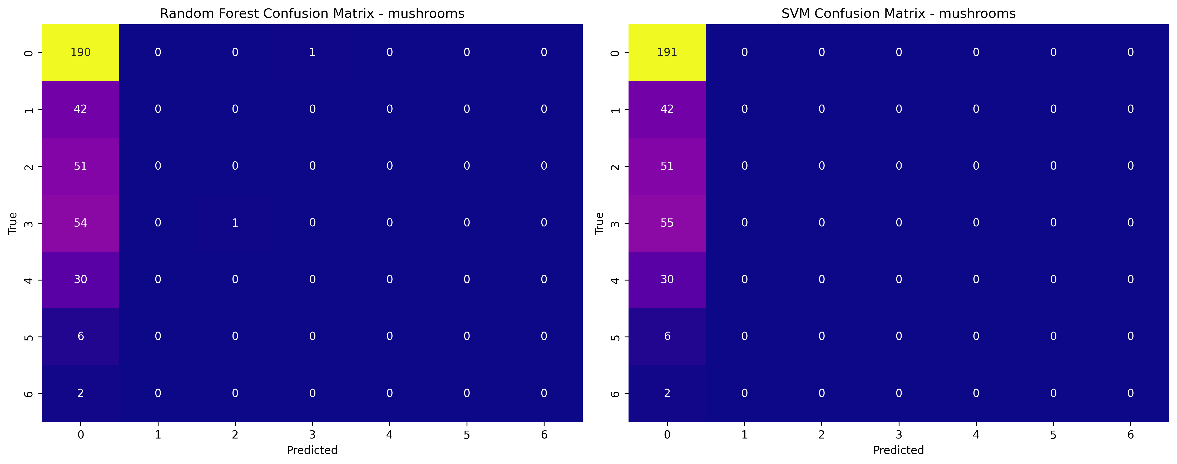

### 4.17 Nicotine

The Random Forest model attained an accuracy of 0.37 for the "nicotine" classification test, with CL6 showing the best performance (precision: 0.41, recall: 0.68, F1-score: 0.51). It had trouble with minority classes; on CL4, CL5, and CL3, it performed zero. Comparable accuracy of 0.39 was achieved by the SVM model, which performed better on CL1 (precision: 0.38), CL6 (precision: 0.40, recall: 0.80, F1-score: 0.53). The weighted average F1-scores and macro scores of both models were low, suggesting poor overall performance.

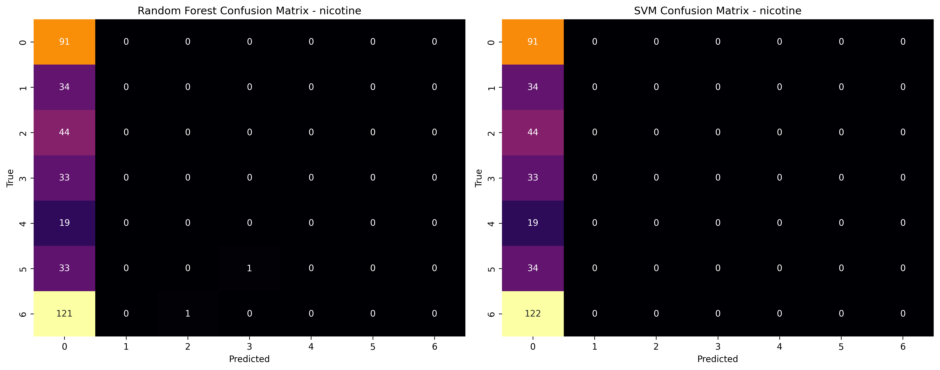

### 4.18 Semer

Both the Random Forest and SVM models had an accuracy of 1.00 for the "semer" classification challenge. With flawless accuracy, recall, and F1-score, both models performed exceptionally well in identifying CL0. However, because the minority class (CL2) only occurs once, they did poorly on it, with 0 accuracy, recall, and F1-score. Although both models' weighted average F1-scores were almost flawless, their macro averages of 0.50 showed that they had trouble generalizing to all classes.

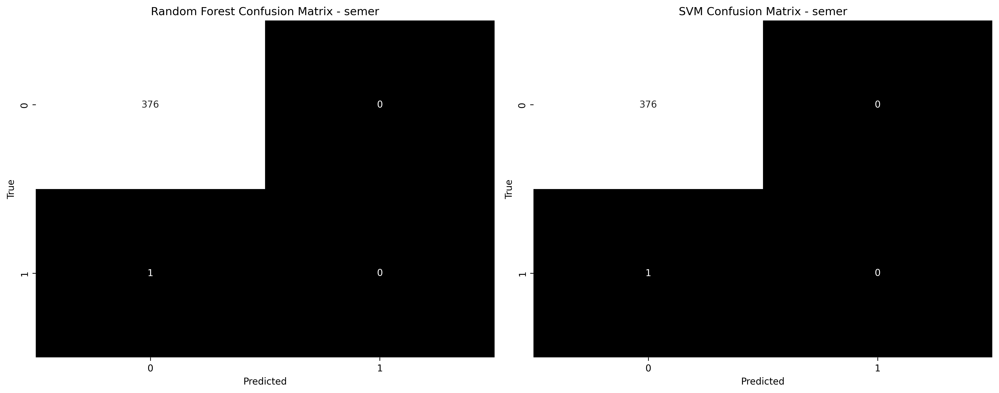

### 4.19 VSA

The Random Forest and SVM models performed similarly on the "vsa" classification. With a high F1-score and faultless recall, the models excelled in class CL0. But because of their poor support, both models had trouble with the minority classes, obtaining 0 accuracy, recall, and F1-score for classes CL1, CL2, CL3, CL4, CL5, and CL6. As a consequence, Random Forest and SVM had accuracy values of 0.76 and 0.77, respectively. Overall performance on the dominating class was strong, but generalisation to the other classes was weak, as indicated by the weighted average F1-scores of 0.66 for Random Forest and 0.67 for SVM. For both models, the macro average F1-scores were extremely low at 0.12.

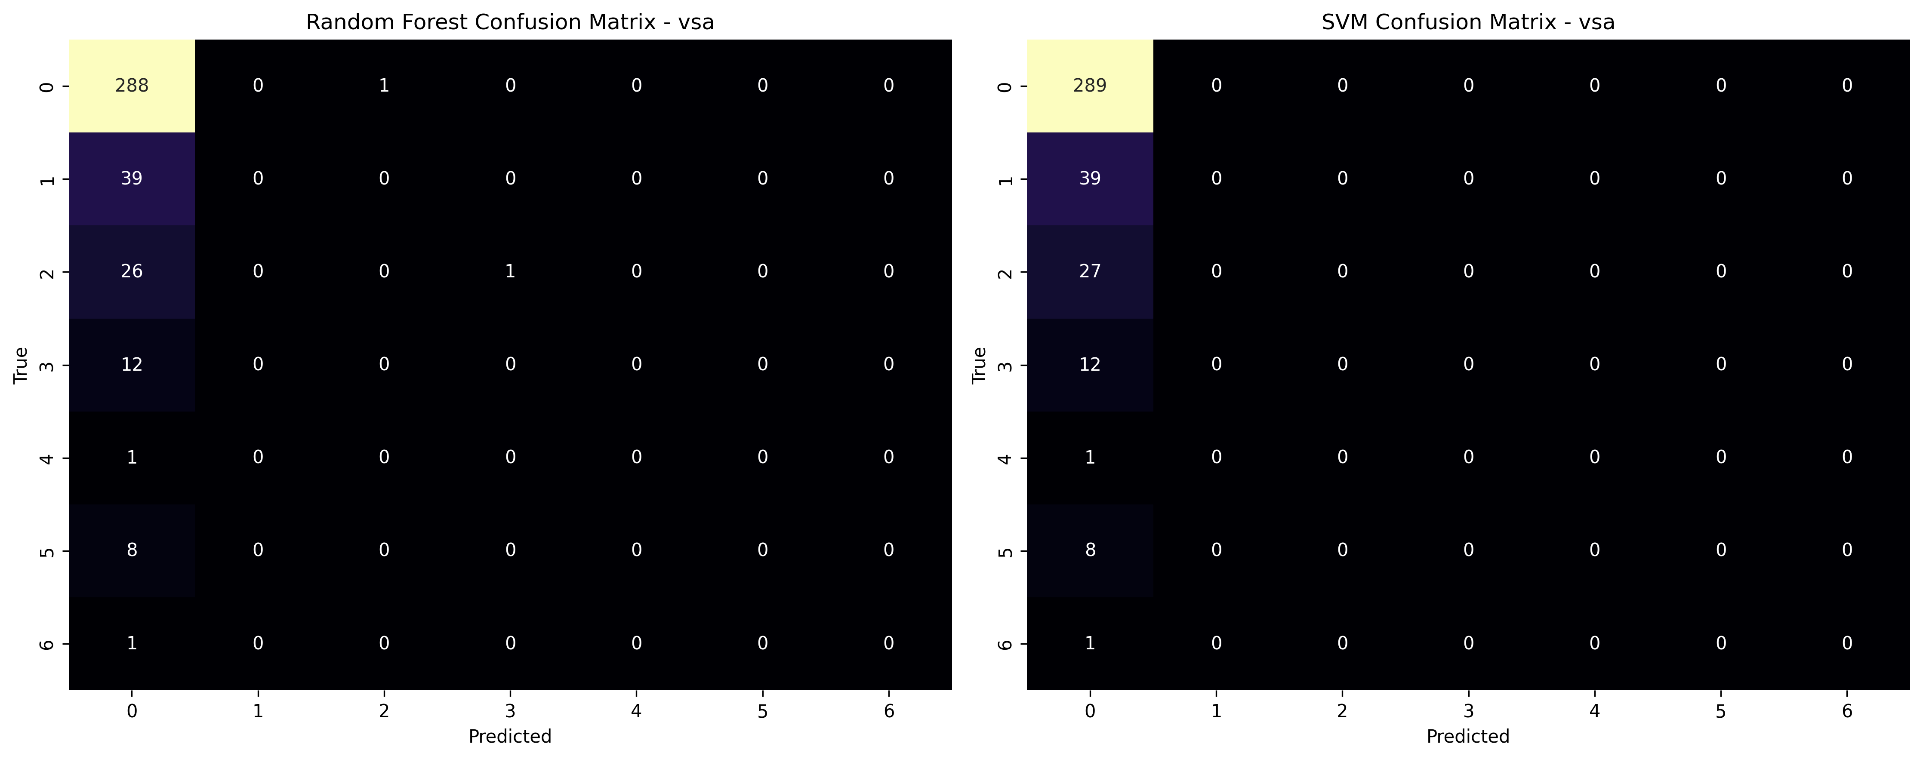

## 5.0 Evaluation and Conclusion

The results showed notable variations in the Random Forest and SVM models' performance across various datasets. The models' performance was assessed using accuracy, precision, recall, and F1-score measures. To evaluate the patterns of misclassification, the confusion matrices were examined.

Random Forest and SVM both performed similarly on the "meth" classification challenge, with Random Forest reaching an accuracy of 73% and SVM earning a slightly better accuracy of 75%. Both models, however, demonstrated poor accuracy, recall, and F1-scores when it came to predicting the minority classes (CL1, CL2, CL3, CL4, CL5, CL6). Low macro averages resulted from both models' difficulties with the smaller classes, however Random Forest performed somewhat better when handling the dominating class (CL0).

Both models performed exceptionally well on the "semer" target classification, with a flawless accuracy of 100%. This was because class CL0, which had 376 samples, dominated the field, but class CL2 only had one sample. With a weighted average F1-score of 1.00, which indicates practically faultless classification on the dominant class, the performance metrics for the two models were almost the same.

Random Forest and SVM performed well on datasets with unbalanced class distributions provided the dominant class had adequate support, but struggled to forecast minority classes. Random Forest performed somewhat better on complicated, non-linear connections, although both models had problems in recognizing less common classes (Breiman, 2001).

## References

1. Breiman, L. (2001). Random Forests. Machine Learning, 45(1), 5–32.  
2. Hosmer, D.W., & Lemeshow, S. (2000). Applied Logistic Regression. John Wiley & Sons.  
3. UCI Machine Learning Repository. (n.d.). Drug Consumption (Quantified). Retrieved from <https://archive.ics.uci.edu/ml/>

4.Sisodia, D., & Sisodia, D. S. (2018). Prediction of diabetes using classification algorithms. *Procedia computer science*, *132*, 1578-1585.